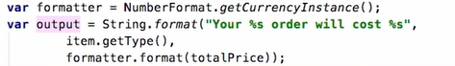

**Package manager – maven, gradle**



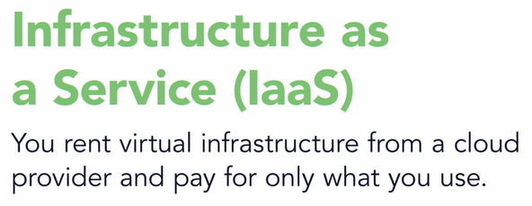

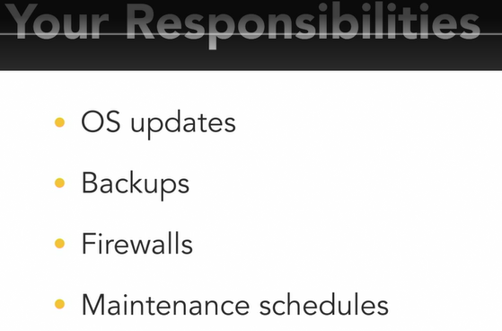

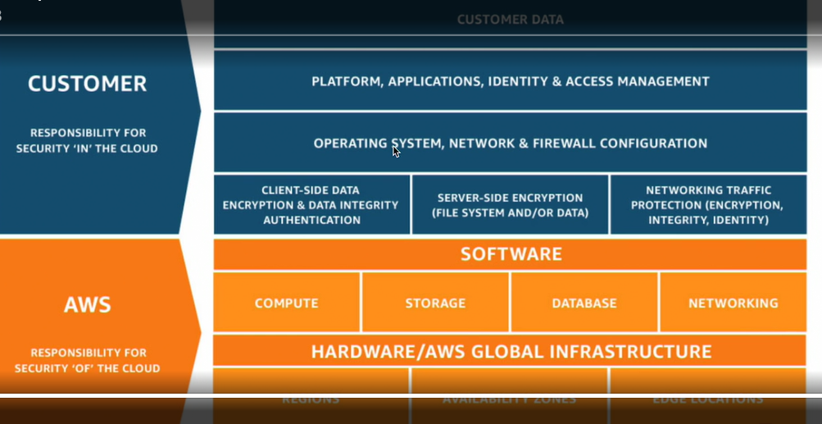

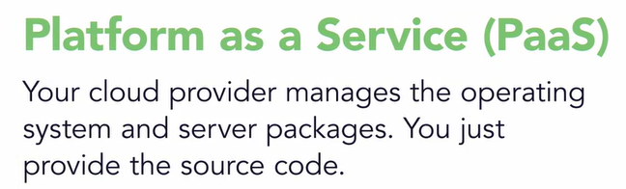

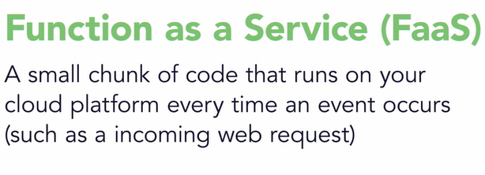



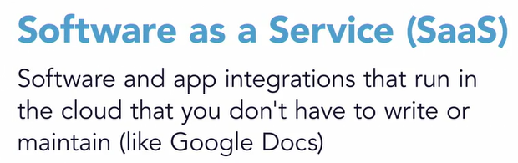

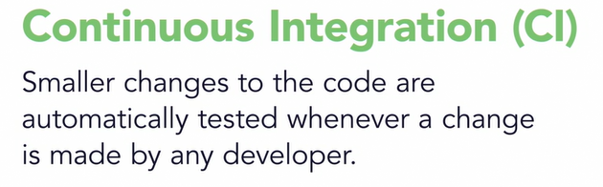

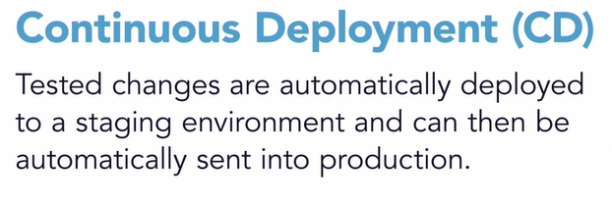

**Fundamentals of Testing**

Software testing is a way to assess the quality of the software and to reduce the risk of software failure in operation.

Software testing is a process which includes many different activities; test execution (including checking of results) is only one of these activities. The test process also includes activities such as test planning, analyzing, designing, and implementing tests, reporting test progress and results, and evaluating the quality of a test object. Some testing does involve the execution of the component or system being tested; such testing is called dynamic testing. Other testing does not involve the execution of the component or system being tested; such testing is called static testing. So, testing also includes reviewing work products such as requirements, user stories, and source code.

Typical Objectives of Testing

• To prevent defects by evaluate work products such as requirements, user stories, design, and code

• To verify whether all specified requirements have been fulfilled

• To check whether the test object is complete and validate if it works as the users and other stakeholders expect

• To build confidence in the level of quality of the test object

• To find defects and failures thus reduce the level of risk of inadequate software quality

• To provide sufficient information to stakeholders to allow them to make informed decisions, especially regarding the level of quality of the test object

• To comply with contractual, legal, or regulatory requirements or standards, and/or to verify the test object’s compliance with such requirements or standards

Another objective of this testing may be to give information to stakeholders about the risk of releasing the system at a given time.

Testing and Debugging

Executing tests can show failures that are caused by defects in the software. Debugging is the development activity that finds, analyzes, and fixes such defects. Subsequent confirmation testing checks whether the fixes resolved the defects. In some cases, testers are responsible for the initial test and the final confirmation test, while developers do the debugging

Why is Testing Necessary?

Rigorous testing of components and systems, and their associated documentation, can help reduce the risk of failures occurring during operation. When defects are detected, and subsequently fixed, this contributes to the quality of the components or systems. In addition, software testing may also be required to meet contractual or legal requirements or industry-specific standards.

Having testers involved in requirements reviews or user story refinement could detect defects in these work products. The identification and removal of requirements defects reduces the risk of incorrect or untestable features being developed.

• Having testers work closely with system designers while the system is being designed can increase each party’s understanding of the design and how to test it. This increased understanding can reduce the risk of fundamental design defects and enable tests to be identified at an early stage.

• Having testers work closely with developers while the code is under development can increase each party’s understanding of the code and how to test it. This increased understanding can reduce the risk of defects within the code and the tests.

• Having testers verify and validate the software prior to release can detect failures that might otherwise have been missed, and support the process of removing the defects that caused the failures (i.e., debugging). This increases the likelihood that the software meets stakeholder needs and satisfies requirements.

Quality Assurance and Testing

Among other activities, quality management includes both quality assurance and quality control.

Quality assurance is typically focused on adherence to proper processes, in order to provide confidence that the appropriate levels of quality will be achieved

Quality control involves various activities, including test activities, that support the achievement of appropriate levels of quality.

Test activities are part of the overall software development or maintenance process. Since quality assurance is concerned with the proper execution of the entire process, quality assurance supports proper testing. Quality assurance include all development process to make quality product where testing is instrument to achieve this.

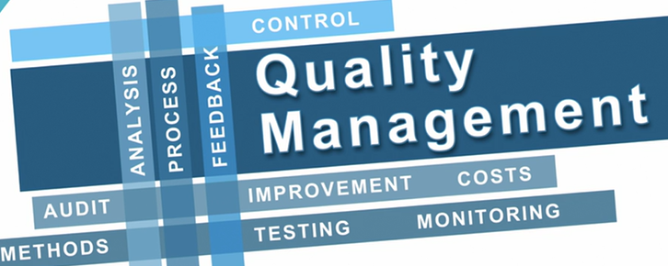

Errors, Defects, and Failures

A person can make an error (mistake), which can lead to the introduction of a defect If a defect in the code is executed, this may cause a failure, but not necessarily in all circumstances. For example, some defects require very specific inputs or preconditions to trigger a failure, which may occur rarely or never.

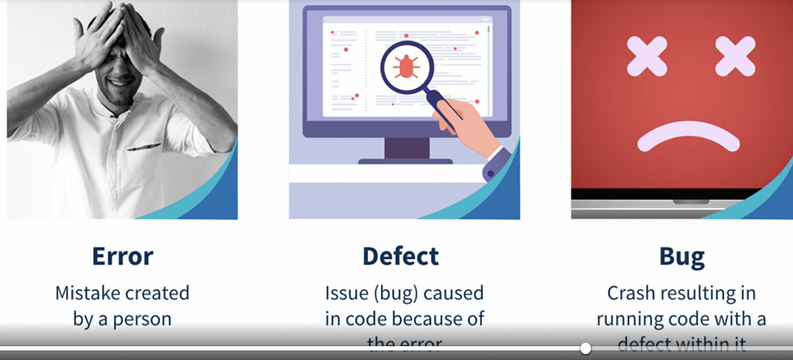

Errors may occur for many reasons, such as:

• Time pressure

• Human fallibility

• Inexperienced or insufficiently skilled project participants

• Miscommunication between project participants, including miscommunication about requirements and design

• Complexity of the code, design, architecture, the underlying problem to be solved, and/or the technologies used

• Misunderstandings about intra-system and inter-system interfaces, especially when such intrasystem and inter-system interactions are large in number

• New, unfamiliar technologies

Not all unexpected test results are failures False positives may occur due to errors in the way tests were executed, or due to defects in the test data, the test environment, or other testware, or for other reasons. False negatives are tests that do not detect defects that they should have detected; false positives are reported as defects, but aren’t actually defects.

Defects, Root Causes and Effects

The root causes of defects are the earliest actions or conditions that contributed to creating the defects. Defects can be analyzed to identify their root causes to prevent a significant number of future defects from being introduced. In this example, the customer complaints are effects. The incorrect interest payments are failures. The improper calculation in the code is a defect, and it resulted from the original defect, the ambiguity in the user story.

Seven Testing Principles

1. Testing shows the presence of defects, not their absence
2. Exhaustive testing is impossible
3. Early testing saves time and money – Early testing is sometimes referred to as shift left.
4. Defects cluster together - A small number of modules usually contains most of the defects discovered during pre-release testing, or is responsible for most of the operational failures
5. Beware of the pesticide paradox - If the same tests are repeated over and over again, eventually these tests no longer find any new defects
6. Testing is context dependent - Testing is done differently in different contexts
7. Absence-of-errors is a fallacy - For example, thoroughly testing all specified requirements and fixing all defects found could still produce a system that is difficult to use, that does not fulfill the users’ needs and expectations

Test Process

These sets of test activities are a test process Which test activities are involved in this test process, how these activities are implemented, and when these activities occur may be discussed in an organization’s test strategy.

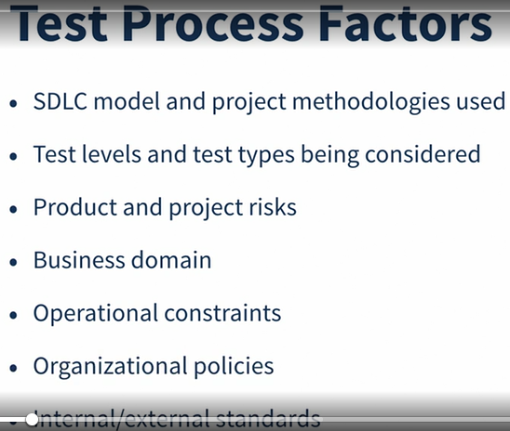

Test Process in Context

• Software development lifecycle model and project methodologies being used

• Test levels and test types being considered

• Product and project risks

• Business domain

• Operational constraints, including but not limited to:

o Budgets and resources

o Timescales

o Complexity

o Contractual and regulatory requirements

• Organizational policies and practices

• Required internal and external standards

The following sections describe general aspects of organizational test processes in terms of the following:

• Test activities and tasks

• Test work products

• Traceability between the test basis and test work products

For example, for a mobile application, the test basis may include a list of requirements and a list of supported mobile devices. Each requirement is an element of the test basis. Each supported device is also an element of the test basis. The coverage criteria may require at least one test case for each element of the test basis. Once executed, the results of these tests tell stakeholders whether specified requirements are fulfilled and whether failures were observed on supported devices.

Test Activities and Tasks A test process consists of the following main groups of activities:

• Test planning

• Test monitoring and control

• Test analysis

• Test design

• Test implementation

• Test execution

• Test completion

Test planning

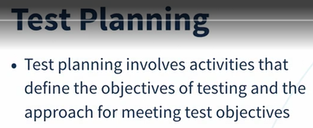

Test planning involves activities that define the objectives of testing and the approach for meeting test objectives within constraints imposed by the context (e.g., specifying suitable test techniques and tasks, and formulating a test schedule for meeting a deadline). Test plans may be revisited based on feedback from monitoring and control activities

Test monitoring and control

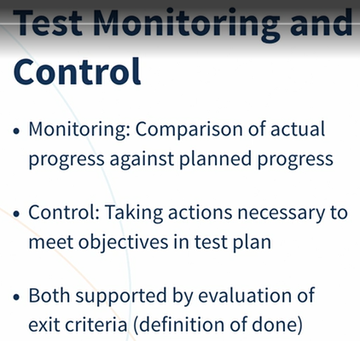

Test monitoring involves the on-going comparison of actual progress against planned progress using any test monitoring metrics defined in the test plan Test monitoring and control are supported by the evaluation of exit criteria, which are referred to as the definition of done in some software development lifecycle models

Checking test results and logs against specified coverage criteria

• Assessing the level of component or system quality based on test results and logs

• Determining if more tests are needed (e.g., if tests originally intended to achieve a certain level of product risk coverage failed to do so, requiring additional tests to be written and executed)

Test analysis

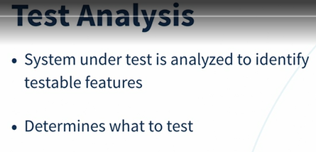

test analysis determines “what to test” in terms of measurable coverage criteria. During test analysis, the test basis is analyzed to identify testable features and define associated test conditions

Analyzing the test basis appropriate to the test level being considered, for example:

o Requirement specifications, such as business requirements, functional requirements, system requirements, user stories, epics, use cases, or similar work products that specify desired functional and non-functional component or system behavior

Such test analysis activities not only verify whether the requirements are consistent, properly expressed, and complete, but also validate whether the requirements properly capture customer, user, and other stakeholder needs. For example, techniques such as behavior driven development (BDD) and acceptance test driven development (ATDD), which involve generating test conditions and test cases from user stories and acceptance criteria prior to coding.

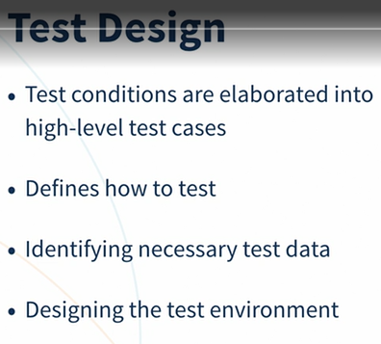

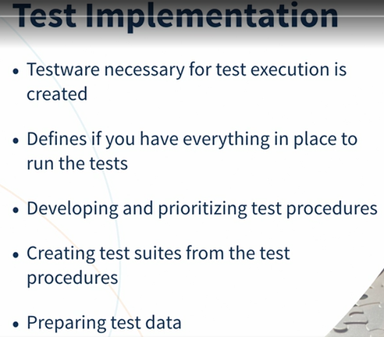

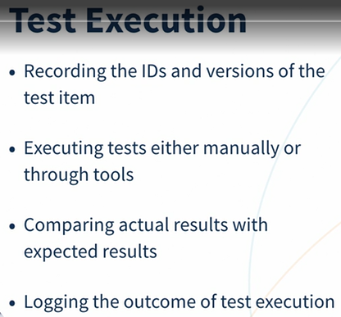

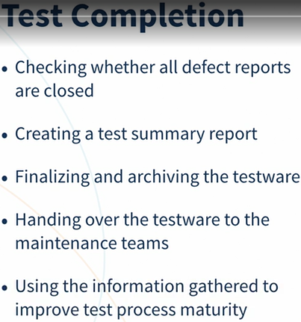

Test completion activities occur at project milestones such as when a software system is released, a test project is completed (or cancelled), an Agile project iteration is finished, a test level is completed, or a maintenance release has been completed.

Test Work Products

Test work products are created as part of the test process.

Test planning work products

The test plan includes information about the test basis, to which the other test work products will be related via traceability information

Test monitoring and control work products

Test monitoring and control work products typically include various types of test reports, including test progress reports produced on an ongoing and/or a regular basis, and test summary reports produced at various completion milestones.

Test analysis work products include defined and prioritized test conditions

Test design results in test cases and sets of test cases to exercise the test conditions defined in test analysis. It is often a good practice to design high-level test cases, without concrete values for input data and expected results

Test conditions defined in test analysis may be further refined in test implementation.

Test implementation work products

Test implementation work products include:

• Test procedures and the sequencing of those test procedures

• Test suites

• A test execution schedule

In some cases, test implementation involves creating work products using or used by tools, such as service virtualization and automated test scripts

Test execution work products include:

• Documentation of the status of individual test cases or test procedures (e.g., ready to run, pass, fail, blocked, deliberately skipped, etc.)

• Defect reports (see section 5.6)

• Documentation about which test item(s), test object(s), test tools, and testware were involved in the testing

Test completion work products

Test completion work products include test summary reports, action items for improvement of subsequent projects or iterations, change requests or product backlog items, and finalized testware.

Traceability between the Test Basis and Test Work Products

good traceability supports:

• Analyzing the impact of changes • Making testing auditable • Meeting IT governance criteria • Improving the understandability of test progress reports and test summary reports to include the status of elements of the test basis (e.g., requirements that passed their tests, requirements that failed their tests, and requirements that have pending tests) • Relating the technical aspects of testing to stakeholders in terms that they can understand • Providing information to assess product quality, process capability, and project progress against business goals

Human Psychology and Testing

confirmation bias can make it difficult to accept information that disagrees with currently held beliefs. For example, since developers expect their code to be correct, they have a confirmation bias that makes it difficult to accept that the code is incorrect To try to reduce these perceptions, information about defects and failures should be communicated in a constructive way. This way, tensions between the testers and the analysts, product owners, designers, and developers can be reduced.

Ways to communicate well include the following examples: • Start with collaboration rather than battles. Remind everyone of the common goal of better quality systems. • Emphasize the benefits of testing. For example, for the authors, defect information can help them improve their work products and their skills. For the organization, defects found and fixed during testing will save time and money and reduce overall risk to product quality. • Communicate test results and other findings in a neutral, fact-focused way without criticizing the person who created the defective item. Write objective and factual defect reports and review findings. • Try to understand how the other person feels and the reasons they may react negatively to the information. • Confirm that the other person has understood what has been said and vice versa.

2 Testing Throughout the Software Development Lifecycle

Keywords acceptance testing, alpha testing, beta testing, change-related testing, commercial off-the-shelf (COTS), component integration testing, component testing, confirmation testing, contractual acceptance testing, functional testing, impact analysis, integration testing, maintenance testing, non-functional testing, operational acceptance testing, regression testing, regulatory acceptance testing, sequential development model, system integration testing, system testing, test basis, test case, test environment, test level, test object, test objective, test type, user acceptance testing, white-box testing

Software Development Lifecycle Models

A software development lifecycle model describes the types of activity performed at each stage in a software development project, and how the activities relate to one another logically and chronologically

Software Development and Software Testing

In any software development lifecycle model, there are several characteristics of good testing: • For every development activity, there is a corresponding test activity • Each test level has test objectives specific to that level • Test analysis and design for a given test level begin during the corresponding development activity • Testers participate in discussions to define and refine requirements and design, and are involved in reviewing work products (e.g., requirements, design, user stories, etc.) as soon as drafts are available

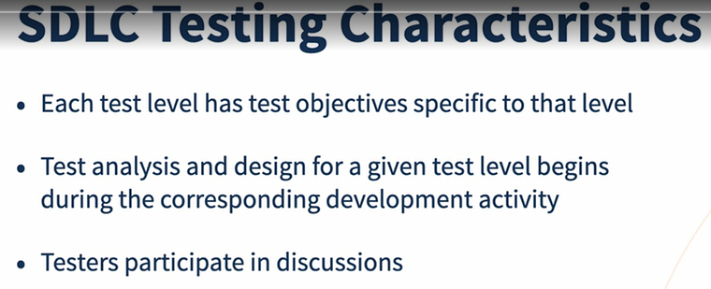

No matter which software development lifecycle model is chosen, test activities should start in the early stages of the lifecycle, adhering to the testing principle of early testing. This syllabus categorizes common software development lifecycle models as follows: • Sequential development models • Iterative and incremental development models A sequential development model describes the software development process as a linear, sequential flow of activities. This means that any phase in the development process should begin when the previous phase is complete.

Sequential development models deliver software that contains the complete set of features, but typically require months or years for delivery to stakeholders and users.

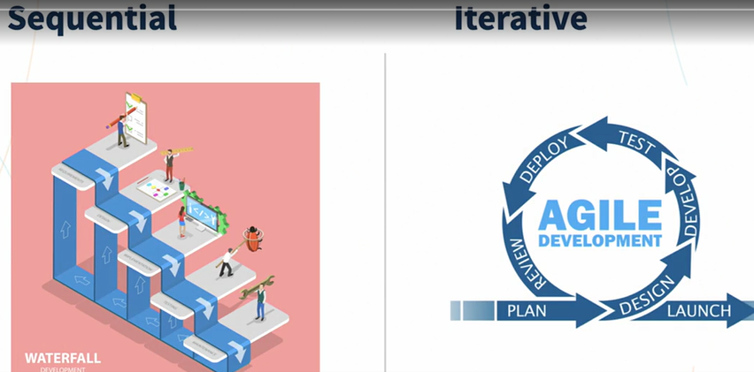

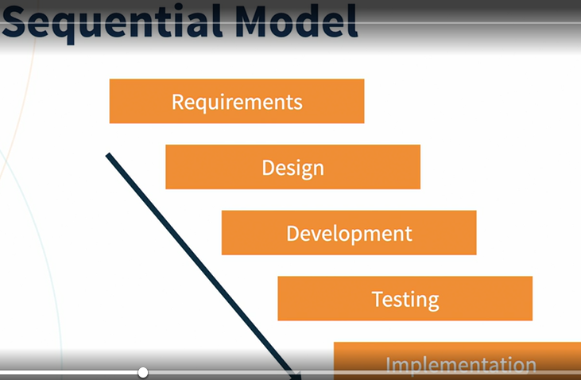

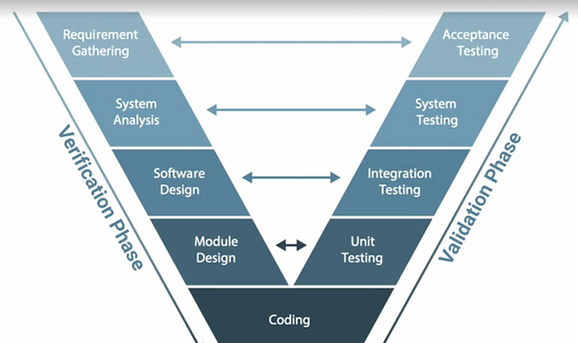

Incremental development involves establishing requirements, designing, building, and testing a system in pieces, which means that the software’s features grow incrementally The feature increments can be as small as a single change to a user interface screen or new query option.

Iterative development occurs when groups of features are specified, designed, built, and tested together in a series of cycles, often of a fixed duration. Iterations may involve changes to features developed in earlier iterations, along with changes in project scope. Each iteration delivers working software which is a growing subset of the overall set of features until the final software is delivered or development is stopped.

Суть данной модели можно изложить в двух частях:

* с точки зрения происходящих процессов модель является **итерационной**, т.е все действия в данной модели повторяются
* с точки зрения развития продукта **инкрементальной**, т.е после каждой итерации происходит приращение полезных функций

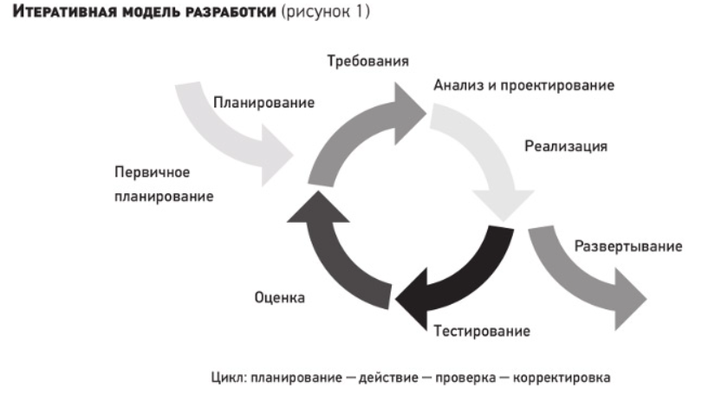

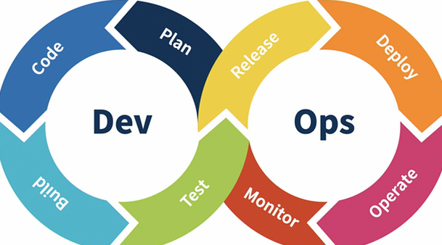

Examples include: • Rational Unified Process: Each iteration tends to be relatively long (e.g., two to three months), and the feature increments are correspondingly large, such as two or three groups of related features • Scrum: Each iteration tends to be relatively short (e.g., hours, days, or a few weeks), and the feature increments are correspondingly small, such as a few enhancements and/or two or three new features • Kanban: Implemented with or without fixed-length iterations, which can deliver either a single enhancement or feature upon completion, or can group features together to release at once • Spiral: Involves creating experimental increments, some of which may be heavily re-worked or even abandoned in subsequent development work

Regardless of whether the software increments are released to end-users, regression testing is increasingly important as the system grows.

Software Development Lifecycle Models in Context

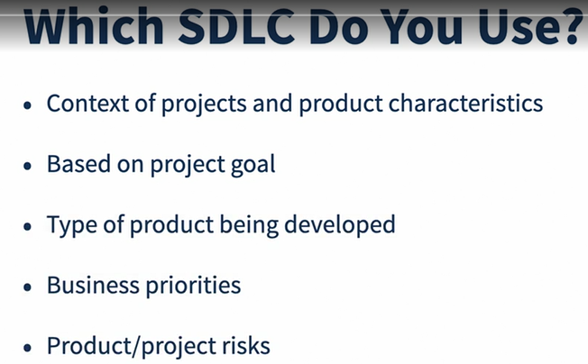

Test Levels

Test levels are groups of test activities that are organized and managed together.

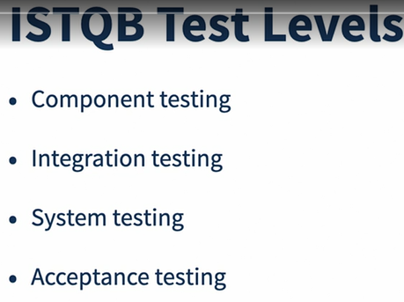

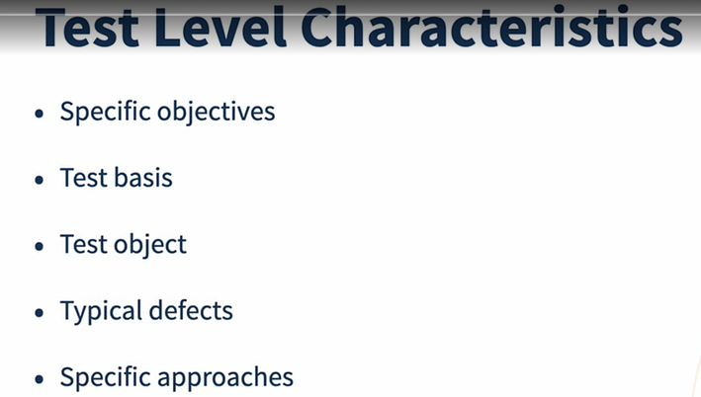

Component Testing (also known as unit or module testing)

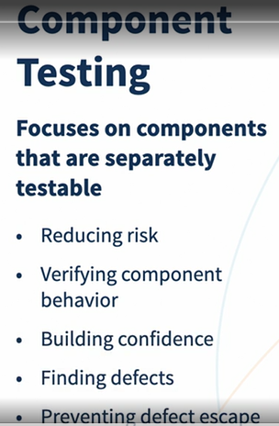

Component testing may cover functionality (e.g., correctness of calculations), non-functional characteristics (e.g., searching for memory leaks), and structural properties (e.g., decision testing).

Test basis Examples of work products that can be used as a test basis for component testing include: • Detailed design • Code • Data model • Component specifications Test objects Typical test objects for component testing include: • Components, units or modules • Code and data structures • Classes • Database modules Typical defects and failures Examples of typical defects and failures for component testing include: • Incorrect functionality (e.g., not as described in design specifications) • Data flow problems • Incorrect code and logic

Defects are typically fixed as soon as they are found, often with no formal defect management. However, when developers do report defects, this provides important information for root cause analysis and process improvement.

Test driven development is an example of a test-first approach. While test driven development originated in eXtreme Programming (XP)

**Extreme programming** (**XP**) is a [software development methodology](https://en.wikipedia.org/wiki/Software_development_methodology) which is intended to improve [software quality](https://en.wikipedia.org/wiki/Software_quality) and responsiveness to changing customer requirements. As a type of [agile software development](https://en.wikipedia.org/wiki/Agile_software_development),[[1]](https://en.wikipedia.org/wiki/Extreme_programming#cite_note-Informatics85-1)[[2]](https://en.wikipedia.org/wiki/Extreme_programming#cite_note-UPenn49-2)[[3]](https://en.wikipedia.org/wiki/Extreme_programming#cite_note-USFCA601-3) it advocates frequent "releases" in short development cycles, which is intended to improve productivity and introduce checkpoints at which new customer requirements can be adopted.

Extreme programming initially recognized four values in 1999: communication, simplicity, feedback, and courage. A new value, respect

Integration Testing

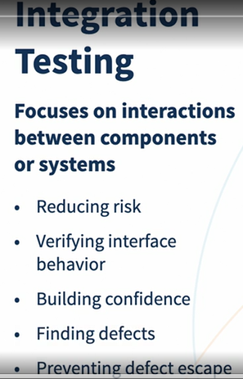

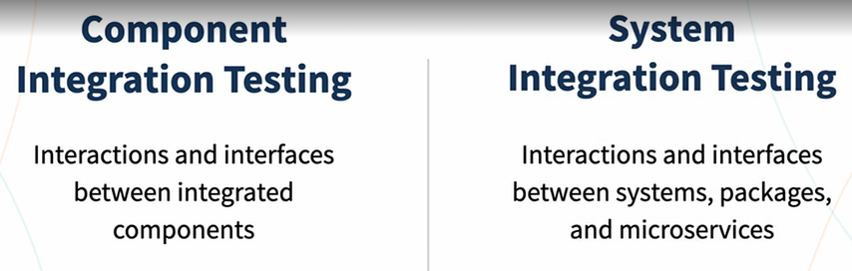

System integration testing can also cover interactions with, and interfaces provided by, external organizations (e.g., web services)

Examples of typical defects and failures for system integration testing include: • Inconsistent message structures between systems • Incorrect data, missing data, or incorrect data encoding • Interface mismatch • Failures in communication between systems • Unhandled or improperly handled communication failures between systems • Incorrect assumptions about the meaning, units, or boundaries of the data being passed between systems • Failure to comply with mandatory security regulations

For example, if integrating module A with module B, tests should focus on the communication between the modules, not the functionality of the individual modules, as that should have been covered during component testing

Component integration testing is often the responsibility of developers. System integration testing is generally the responsibility of testers.

System Testing

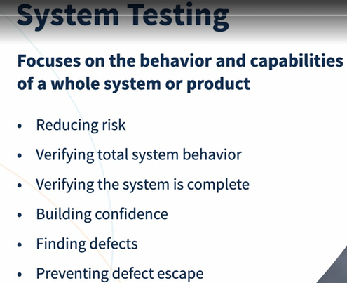

Typical defects and failures Examples of typical defects and failures for system testing include: • Incorrect calculations • Incorrect or unexpected system functional or non-functional behavior • Incorrect control and/or data flows within the system • Failure to properly and completely carry out end-to-end functional tasks • Failure of the system to work properly in the system environment(s) • Failure of the system to work as described in system and user manuals

System testing should focus on the overall, end-to-end behavior of the system as a whole, both functional and non-functional

Defects in specifications (e.g., missing user stories, incorrectly stated business requirements, etc.) can lead to a lack of understanding of, or disagreements about, expected system behavior. Such situations can cause false positives and false negatives, which waste time and reduce defect detection effectiveness, respectively

Acceptance Testing

User acceptance testing (UAT)

The main objective is building confidence that the users can use the system to meet their needs, fulfill requirements, and perform business processes with minimum difficulty, cost, and risk.

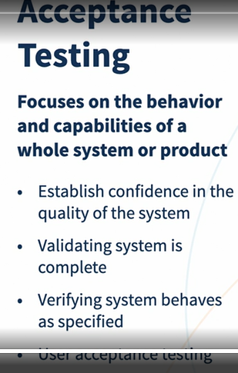

Operational acceptance testing (OAT)

The tests focus on operational aspects, and may include: • Testing of backup and restore • Installing, uninstalling and upgrading • Disaster recovery • User management • Maintenance tasks

The main objective of operational acceptance testing is building confidence that the operators or system administrators can keep the system working properly for the users in the operational environment, even under exceptional or difficult conditions.

Contractual acceptance testing is often performed by users or by independent testers.

Regulatory acceptance testing is performed against any regulations that must be adhered to, such as government, legal, or safety regulations

Alpha testing is performed at the developing organization’s site, not by the development team, but by potential or existing customers, and/or operators or an independent test team. Beta testing is performed by potential or existing customers, and/or operators at their own locations

Typical defects and failures Examples of typical defects for any form of acceptance testing include: • System workflows do not meet business or user requirements • Business rules are not implemented correctly • System does not satisfy contractual or regulatory requirements • Non-functional failures such as security vulnerabilities, inadequate performance efficiency under high loads, or improper operation on a supported platform

In iterative development, project teams can employ various forms of acceptance testing during and at the end of each iteration, such as those focused on verifying a new feature against its acceptance criteria and those focused on validating that a new feature satisfies the users’ needs.

Test Types

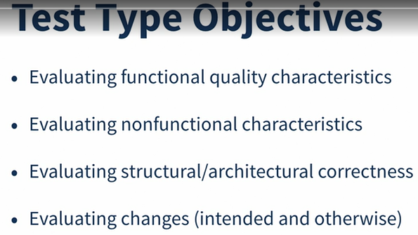

Functional Testing

Functional testing of a system involves tests that evaluate functions that the system should perform. Functional requirements may be described in work products such as business requirements specifications, epics, user stories, use cases, or functional specifications, or they may be undocumented.

The functions are “what” the system should do.

using traceability between tests and functional requirements, the percentage of these requirements which are addressed by testing can be calculated, potentially identifying coverage gaps.

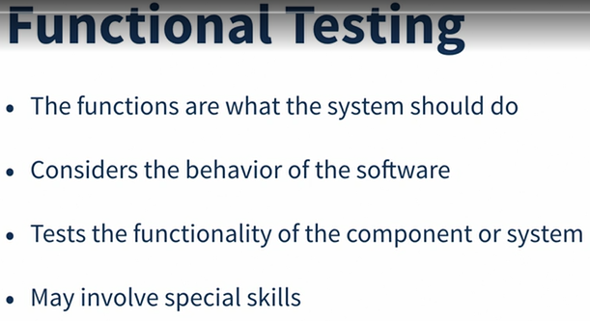

Non-functional Testing

Non-functional testing of a system evaluates characteristics of systems and software such as usability, performance efficiency or security

Non-functional testing is the testing of “how well” the system behaves.

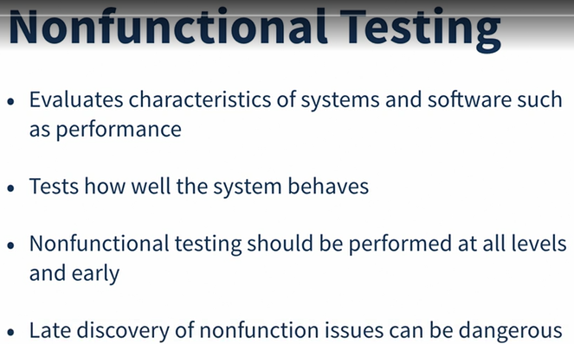

White-box Testing

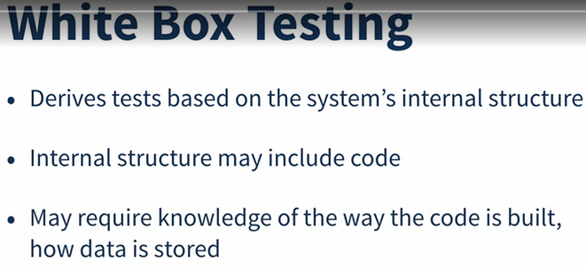

Change-related Testing

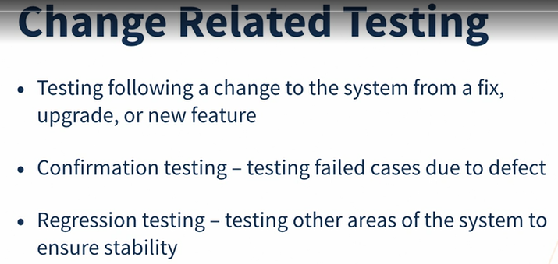

Test Types and Test Levels

Компонентное тестирование: тесты разрабатываются на основе того, как компонент должен вычислять сложные проценты ● Тестирование интеграции компонентов: тесты разрабатываются на основе того, как информация учетной записи, созданная в пользовательском интерфейсе, передается модулю бизнес-логики ● Системное тестирование: тесты разрабатываются на основе того, как владельцы счетов могут подать заявку на кредитную линию на своих расчетных счетах ● Системное интеграционное тестирование: тесты разрабатываются на основе того, как система использует внешний микросервис для проверки кредитного рейтинга владельца счета ● Приемочное тестирование: тесты разрабатываются на основе того, как банкир обрабатывает одобрение или отклонение заявки на получение кредита Примерами нефункциональных тестов являются: ● Компонентное тестирование: разрабатываются тесты производительности, предназначенные для оценки количества циклов ЦП, необходимых для выполнения расчета сложных процентов ● Тестирование интеграции компонентов: разрабатываются тесты на защищенность от уязвимостей при переполнении буфера данными, переданными из пользовательского интерфейса в модуль бизнес-логики ● Системное тестирование: разрабатываются тесты на переносимость, предназначенные для проверки того, работает ли слой представления во всех поддерживаемых браузерах и мобильных устройствах ● Системное интеграционное тестирование: разрабатываются тесты надежности, предназначенные для оценки работоспособности системы, если микросервис кредитной оценки не отвечает ● Приемочное тестирование: разрабатываются тесты практичности, предназначенные для оценки доступности интерфейса обработки банковских процессов для людей с ограниченными возможностями

Maintenance Testing

Once deployed to production environments, software and systems need to be maintained

Maintenance can involve planned releases and unplanned releases (hot fixes).

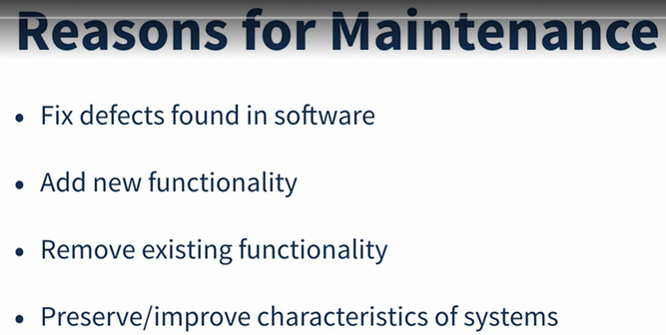

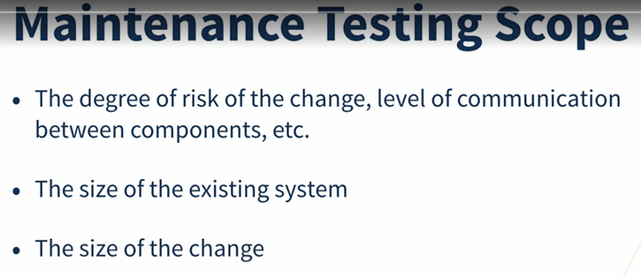

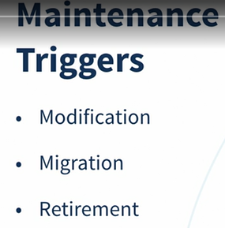

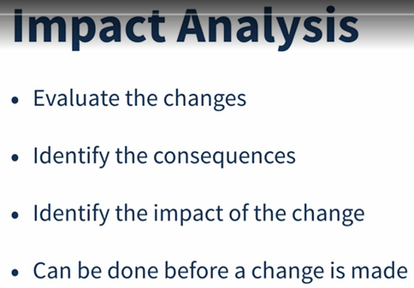

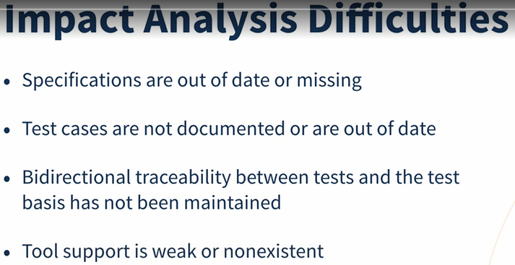

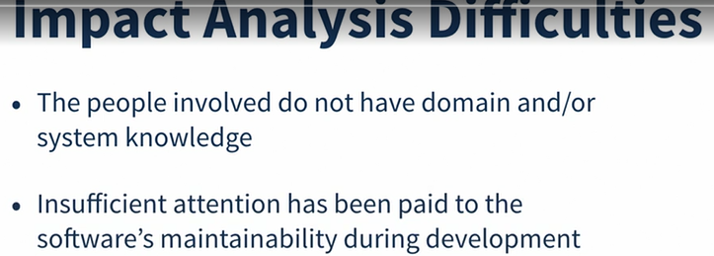

Static Testing

Keywords

ad hoc review, checklist-based review, dynamic testing, formal review, informal review, inspection, perspective-based reading, review, role-based review, scenario-based review, static analysis, static testing, technical review, walkthrough  
Static Testing Basics

In contrast to dynamic testing, which requires the execution of the software being tested, static testing relies on the manual examination of work products (i.e., reviews) or tool-driven evaluation of the code or other work products (i.e., static analysis). Both types of static testing assess the code or other work product being tested without actually executing the code or work product being tested.

For example, static analysis is an important part of security testing.

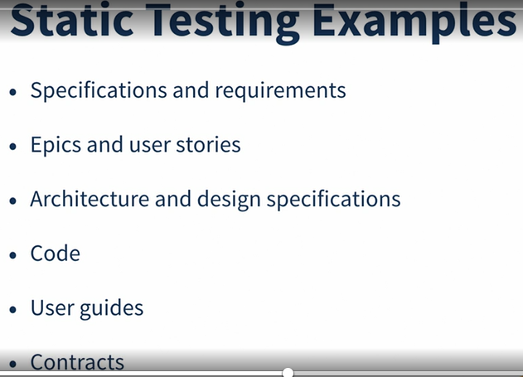

Benefits of Static Testing

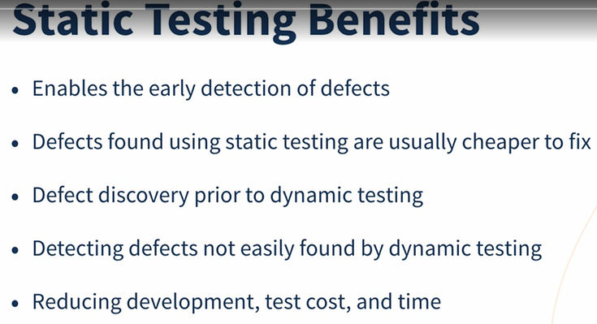

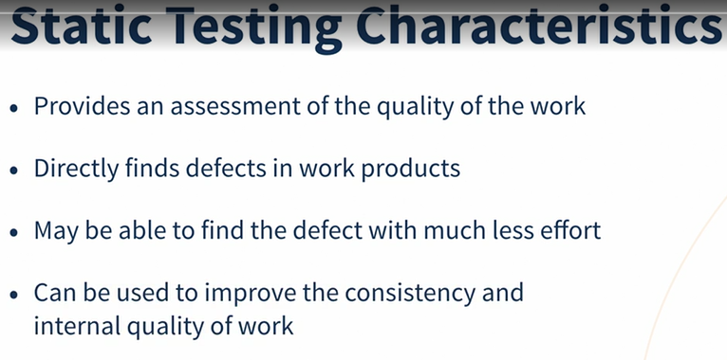

Differences between Static and Dynamic Testing

Static and dynamic testing complement each other by finding different types of defects.

One main distinction is that static testing finds defects in work products directly rather than identifying failures caused by defects when the software is run . A defect can reside in a work product for a very long time without causing a failure. The path where the defect lies may be rarely exercised or hard to reach, so it will not be easy to construct and execute a dynamic test that encounters it.

static testing include:

Requirement defects (e.g., inconsistencies, ambiguities, contradictions, omissions, inaccuracies, and redundancies) • Design defects (e.g., inefficient algorithms or database structures, high coupling, low cohesion) • Coding defects (e.g., variables with undefined values, variables that are declared but never used, unreachable code, duplicate code) • Deviations from standards (e.g., lack of adherence to coding standards) • Incorrect interface specifications (e.g., different units of measurement used by the calling system than by the called system) • Security vulnerabilities (e.g., susceptibility to buffer overflows) • Gaps or inaccuracies in test basis traceability or coverage (e.g., missing tests for an acceptance

Moreover, most types of maintainability defects can only be found by static testing (e.g., improper modularization, poor reusability of components, code that is difficult to analyze and modify without introducing new defects).

Review Process

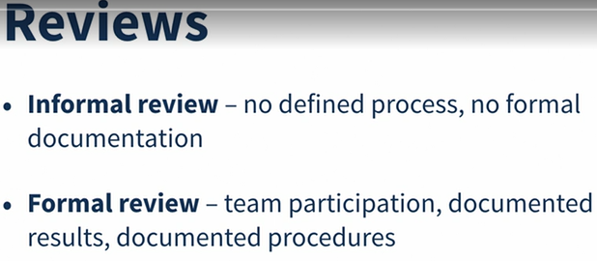

Work Product Review Process

Planning • Defining the scope, which includes the purpose of the review, what documents or parts of documents to review, and the quality characteristics to be evaluated • Estimating effort and timeframe • Identifying review characteristics such as the review type with roles, activities, and checklists • Selecting the people to participate in the review and allocating roles • Defining the entry and exit criteria for more formal review types (e.g., inspections) • Checking that entry criteria are met (for more formal review types) Initiate review • Distributing the work product (physically or by electronic means) and other material, such as issue log forms, checklists, and related work products • Explaining the scope, objectives, process, roles, and work products to the participants • Answering any questions that participants may have about the review Individual review (i.e., individual preparation) • Reviewing all or part of the work product • Noting potential defects, recommendations, and questions Issue communication and analysis • Communicating identified potential defects (e.g., in a review meeting) • Analyzing potential defects, assigning ownership and status to them • Evaluating and documenting quality characteristics • Evaluating the review findings against the exit criteria to make a review decision (reject; major changes needed; accept, possibly with minor changes)

Fixing and reporting • Creating defect reports for those findings that require changes to a work product • Fixing defects found (typically done by the author) in the work product reviewed • Communicating defects to the appropriate person or team (when found in a work product related to the work product reviewed) • Recording updated status of defects (in formal reviews), potentially including the agreement of the comment originator • Gathering metrics (for more formal review types) • Checking that exit criteria are met (for more formal review types) • Accepting the work product when the exit criteria are reached

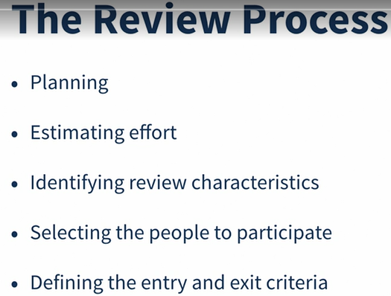

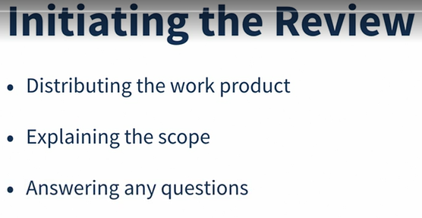

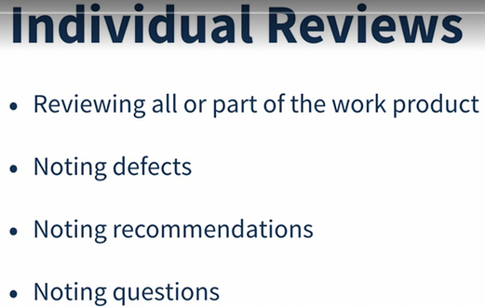

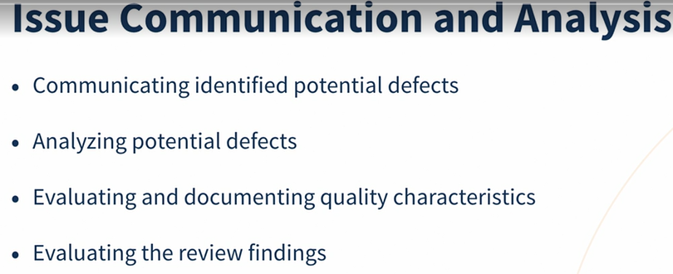

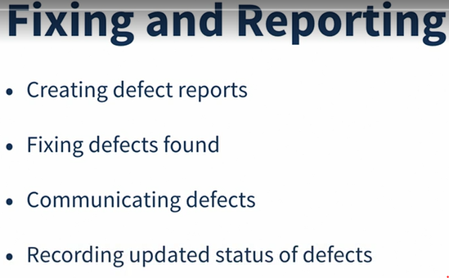

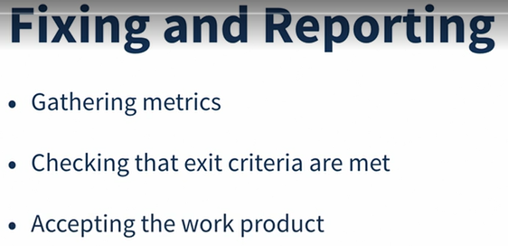

Roles and responsibilities in a formal review

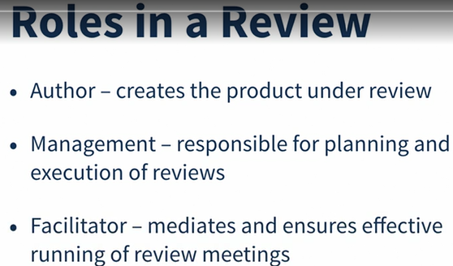

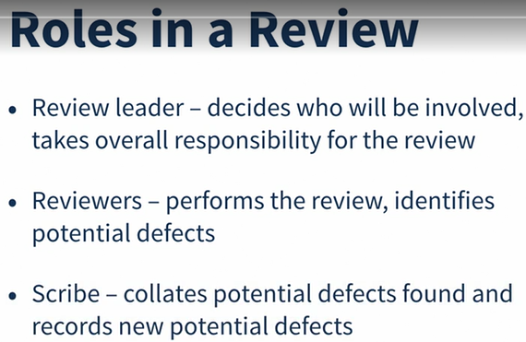

Author • Creates the work product under review • Fixes defects in the work product under review (if necessary) Management • Is responsible for review planning • Decides on the execution of reviews • Assigns staff, budget, and time • Monitors ongoing cost-effectiveness • Executes control decisions in the event of inadequate outcomes Facilitator (often called moderator) • Ensures effective running of review meetings (when held) • Mediates, if necessary, between the various points of view • Is often the person upon whom the success of the review depends Review leader • Takes overall responsibility for the review • Decides who will be involved and organizes when and where it will take place

Reviewers • May be subject matter experts, persons working on the project, stakeholders with an interest in the work product, and/or individuals with specific technical or business backgrounds • Identify potential defects in the work product under review • May represent different perspectives (e.g., tester, developer, user, operator, business analyst, usability expert, etc.) Scribe (or recorder) • Collates potential defects found during the individual review activity • Records new potential defects, open points, and decisions from the review meeting (when held)

In some review types, one person may play more than one role, and the actions associated with each role may also vary based on review type.

Review Types

For example, an informal review may be carried out before a technical review, to ensure the work product is ready for a technical review.

Informal review (e.g., buddy check, pairing, pair review) • Main purpose: detecting potential defects • Possible additional purposes: generating new ideas or solutions, quickly solving minor problems • Not based on a formal (documented) process • May not involve a review meeting • May be performed by a colleague of the author (buddy check) or by more people • Results may be documented • Varies in usefulness depending on the reviewers • Use of checklists is optional • Very commonly used in Agile development

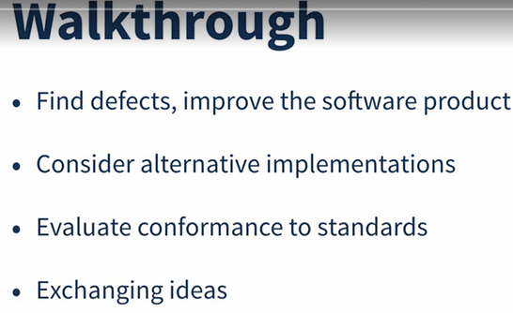

Walkthrough • Main purposes: find defects, improve the software product, consider alternative implementations, evaluate conformance to standards and specifications • Possible additional purposes: exchanging ideas about techniques or style variations, training of participants, achieving consensus • Individual preparation before the review meeting is optional • Review meeting is typically led by the author of the work product • Scribe is mandatory • Use of checklists is optional • May take the form of scenarios, dry runs, or simulations • Potential defect logs and review reports are produced • May vary in practice from quite informal to very formal

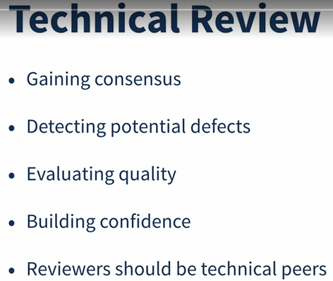

Technical review • Main purposes: gaining consensus, detecting potential defects • Possible further purposes: evaluating quality and building confidence in the work product, generating new ideas, motivating and enabling authors to improve future work products, considering alternative implementations • Reviewers should be technical peers of the author, and technical experts in the same or other disciplines • Individual preparation before the review meeting is required • Review meeting is optional, ideally led by a trained facilitator (typically not the author) • Scribe is mandatory, ideally not the author • Use of checklists is optional • Potential defect logs and review reports are produced

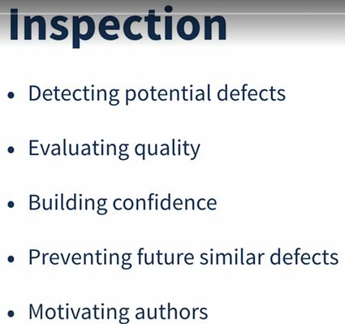

Applying Review Techniques

Ad hoc

In an ad hoc review, reviewers are provided with little or no guidance on how this task should be performed. Reviewers often read the work product sequentially, identifying and documenting issues as they encounter them

Checklist-based

A checklist-based review is a systematic technique, whereby the reviewers detect issues based on checklists that are distributed at review initiation (e.g., by the facilitator). A review checklist consists of a set of questions based on potential defects, which may be derived from experience.

Scenarios and dry runs

In a scenario-based review, reviewers are provided with structured guidelines on how to read through the work product. A scenario-based review supports reviewers in performing “dry runs” on the work product based on expected usage of the work product These scenarios provide reviewers with better guidelines on how to identify specific defect types than simple checklist entries.

Perspective-based

In perspective-based reading, similar to a role-based review, reviewers take on different stakeholder viewpoints in individual reviewing. Typical stakeholder viewpoints include end user, marketing, designer, tester, or operations. Using different stakeholder viewpoints leads to more depth in individual reviewing with less duplication of issues across reviewers

Empirical studies have shown perspective-based reading to be the most effective general technique for reviewing requirements and technical work products

Role-based

A role-based review is a technique in which the reviewers evaluate the work product from the perspective of individual stakeholder roles. Typical roles include specific end user types (experienced, inexperienced, senior, child, etc.), and specific roles in the organization (user administrator, system administrator, performance tester, etc.). The same principles apply as in perspective-based reading because the roles are similar

Success Factors for Reviews

Organizational success factors for reviews include: • Each review has clear objectives, defined during review planning, and used as measurable exit criteria • Review types are applied which are suitable to achieve the objectives and are appropriate to the type and level of software work products and participants • Any review techniques used, such as checklist-based or role-based reviewing, are suitable for effective defect identification in the work product to be reviewed • Any checklists used address the main risks and are up to date • Large documents are written and reviewed in small chunks, so that quality control is exercised by providing authors early and frequent feedback on defects • Participants have adequate time to prepare • Reviews are scheduled with adequate notice • Management supports the review process (e.g., by incorporating adequate time for review activities in project schedules) • Reviews are integrated in the company's quality and/or test policies

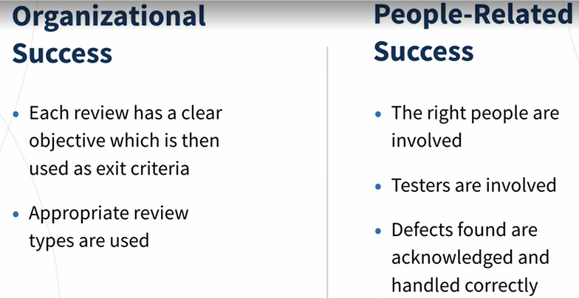

Test Techniques

Keywords

black-box test technique, boundary value analysis, checklist-based testing, coverage, decision coverage, decision table testing, error guessing, equivalence partitioning, experience-based test technique, exploratory testing, state transition testing, statement coverage, test technique, use case testing, whitebox test technique

Categories of Test Techniques

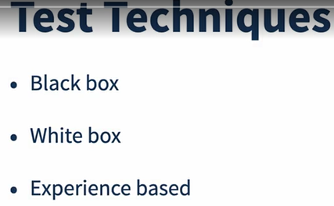

Black-box test techniques (also called behavioral or behavior-based techniques) are based on an analysis of the appropriate test basis (e.g., formal requirements documents, specifications, use cases, user stories, or business processes). These techniques are applicable to both functional and nonfunctional testing. Black-box test techniques concentrate on the inputs and outputs of the test object without reference to its internal structure.

White-box test techniques (also called structural or structure-based techniques) are based on an analysis of the architecture, detailed design, internal structure, or the code of the test object. Unlike black-box test techniques, white-box test techniques concentrate on the structure and processing within the test object.

Experience-based test techniques leverage the experience of developers, testers and users to design, implement, and execute tests. These techniques are often combined with black-box and white-box test techniques.

Black-box Test Techniques

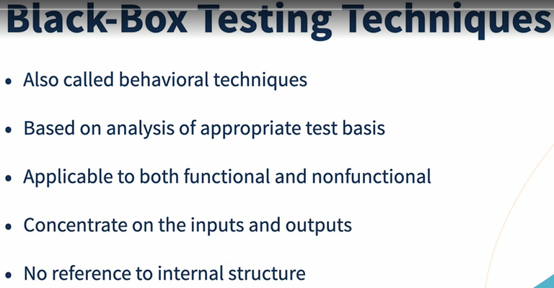

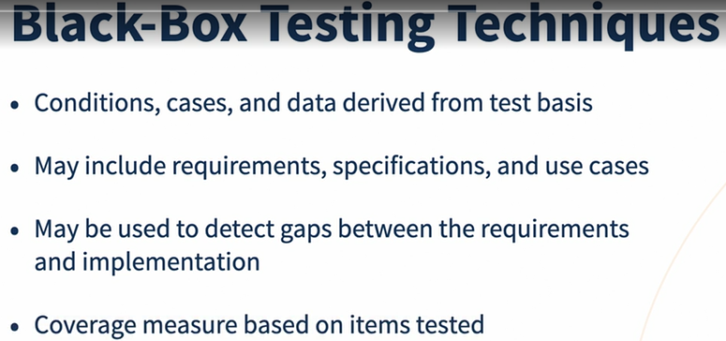

Equivalence Partitioning

Equivalence partitioning divides data into partitions (also known as equivalence classes) in such a way that all the members of a given partition are expected to be processed in the same way

There are equivalence partitions for both valid and invalid values.

• Valid values are values that should be accepted by the component or system. An equivalence partition containing valid values is called a “valid equivalence partition.”

• Invalid values are values that should be rejected by the component or system. An equivalence partition containing invalid values is called an “invalid equivalence partition.”

Each value must belong to one and only one equivalence partition

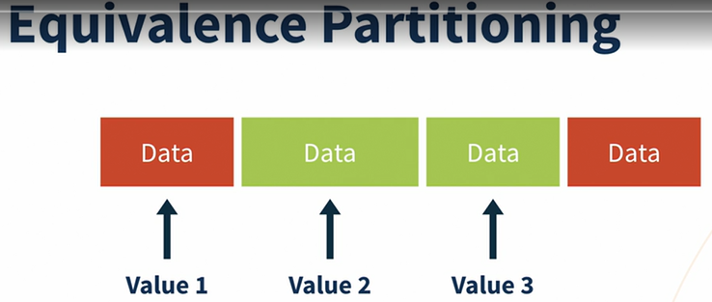

To achieve 100% coverage with this technique, test cases must cover all identified partitions (including invalid partitions) by using a minimum of one value from each partition

Boundary Value Analysis

Boundary value analysis (BVA) is an extension of equivalence partitioning The minimum and maximum values (or first and last values) of a partition are its boundary values

For example, suppose an input field accepts a single integer value as an input, using a keypad to limit inputs so that non-integer inputs are impossible. The valid range is from 1 to 5, inclusive. So, there are three equivalence partitions: invalid (too low); valid; invalid (too high)

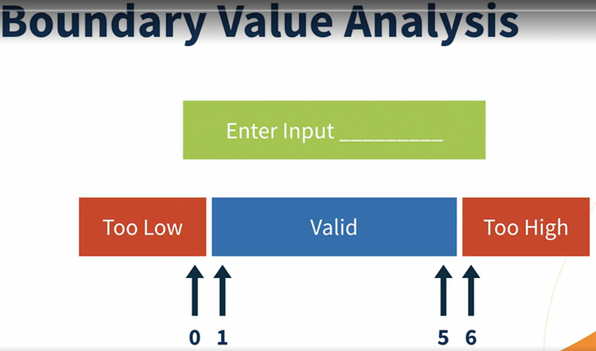

Decision Table Testing

Decision tables are a good way to record complex business rules that a system must implement. When creating decision tables, the tester identifies conditions (often inputs) and the resulting actions (often outputs) of the system

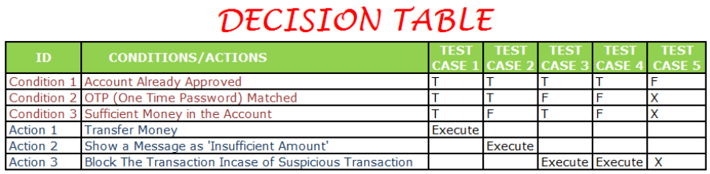

A full decision table has enough columns (test cases) to cover every combination of conditions

Coverage is measured as the number of decision rules tested by at least one test case, divided by the total number of decision rules, normally expressed as a percentage.

State Transition Testing

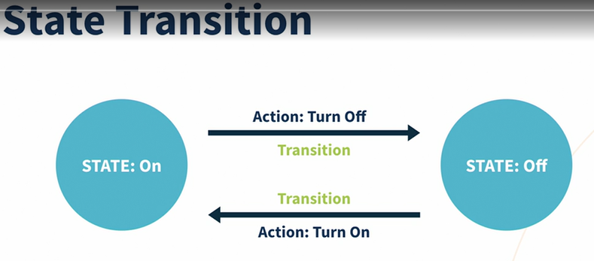

A state transition diagram shows the possible software states, as well as how the software enters, exits, and transitions between states. A transition is initiated by an event (e.g., user input of a value into a field). The event results in a transition. The same event can result in two or more different transitions from the same state. The state change may result in the software taking an action (e.g., outputting a calculation or error message).

State transition diagrams normally show only the valid transitions and exclude the invalid transitions.

State transition testing is used for menu-based applications and is widely used within the embedded software industry. The technique is also suitable for modeling a business scenario having specific states or for testing screen navigation

Coverage is commonly measured as the number of identified states or transitions tested, divided by the total number of identified states or transitions in the test object, normally expressed as a percentage

Use Case Testing

Tests can be derived from use cases, which are a specific way of designing interactions with software items. They incorporate requirements for the software functions. Use cases are associated with actors (human users, external hardware, or other components or systems)

Each use case specifies some behavior that a subject can perform in collaboration with one or more actors

A use case can include possible variations of its basic behavior, including exceptional behavior and error handling (system response and recovery from programming, application and communication errors, e.g., resulting in an error message).

. Tests are designed to exercise the defined behaviors (basic, exceptional or alternative, and error handling).

White-box Test Techniques

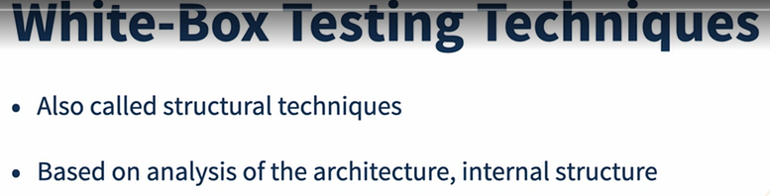

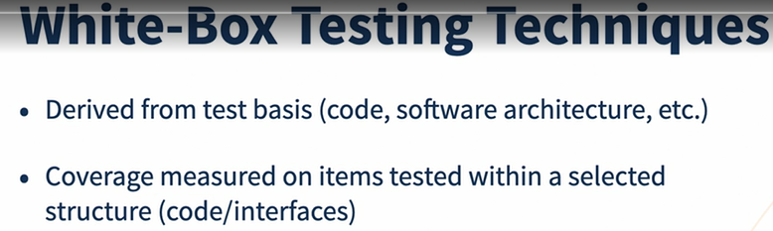

White-box test techniques can be used at all test levels, but the two code-related techniques discussed in this section are most commonly used at the component test level.

Statement Testing and Coverage

Statement testing exercises the potential executable statements in the code

Decision Testing and Coverage

Decision testing exercises the decisions in the code and tests the code that is executed based on the decision outcomes. To do this, the test cases follow the control flows that occur from a decision point (e.g., for an IF statement, one for the true outcome and one for the false outcome; for a CASE statement, test cases would be required for all the possible outcomes, including the default outcome).

The Value of Statement and Decision Testing

When 100% statement coverage is achieved, it ensures that all executable statements in the code have been tested at least once, but it does not ensure that all decision logic has been tested. Of the two whitebox techniques discussed in this syllabus, statement testing may provide less coverage than decision testing.

When 100% decision coverage is achieved, it executes all decision outcomes, which includes testing the true outcome and also the false outcome, even when there is no explicit false statement (e.g., in the case of an IF statement without an else in the code). Statement coverage helps to find defects in code that was not exercised by other tests. Decision coverage helps to find defects in code where other tests have not taken both true and false outcomes.

Achieving 100% decision coverage guarantees 100% statement coverage (but not vice versa)

Experience-based Test Techniques

When applying experience-based test techniques, the test cases are derived from the tester’s skill and intuition, and their experience with similar applications and technologies. These techniques can be helpful in identifying tests that were not easily identified by other more systematic techniques.

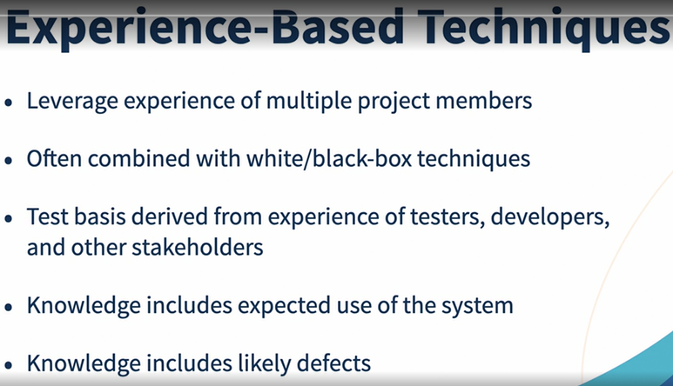

Error Guessing

Error guessing is a technique used to anticipate the occurrence of errors, defects, and failures, based on the tester’s knowledge, including: • How the application has worked in the past • What kind of errors tend to be made • Failures that have occurred in other applications

Exploratory Testing

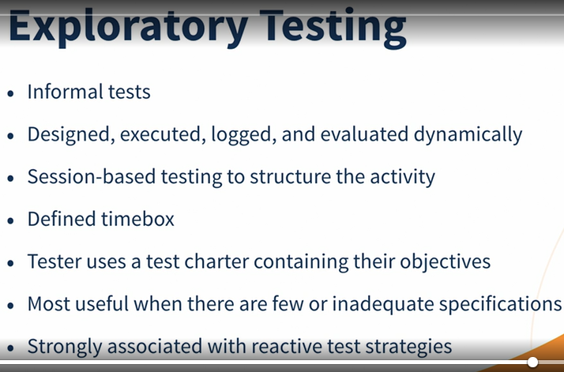

In exploratory testing, informal (not pre-defined) tests are designed, executed, logged, and evaluated dynamically during test execution. The test results are used to learn more about the component or system, and to create tests for the areas that may need more testing.

Exploratory testing is most useful when there are few or inadequate specifications or significant time pressure on testing

Exploratory testing is sometimes conducted using session-based testing to structure the activity

Checklist-based Testing

In checklist-based testing, testers design, implement, and execute tests to cover test conditions found in a checklist. As part of analysis, testers create a new checklist or expand an existing checklist, but testers may also use an existing checklist without modification. Such checklists can be built based on experience, knowledge about what is important for the user, or an understanding of why and how software fails.

an experience-based test technique whereby the experienced tester uses a list of items to be noted, checked, or remembered, or a set of rules or criteria against which a product must be verified

Test Management

Keywords

configuration management, defect management, defect report, entry criteria, exit criteria, product risk, project risk, risk, risk level, risk-based testing, test approach, test control, test estimation, test manager, test monitoring, test plan, test planning, test progress report, test strategy, test summary report, tester

Test Organization

Independent Testing

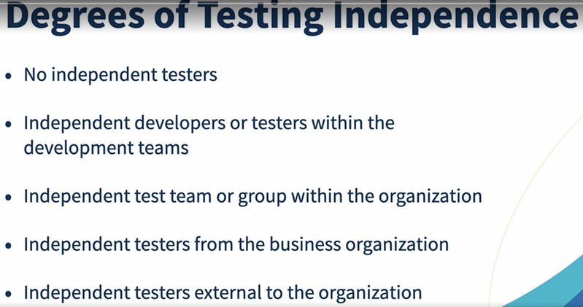

Potential benefits of test independence include: • Independent testers are likely to recognize different kinds of failures compared to developers because of their different backgrounds, technical perspectives, and biases • An independent tester can verify, challenge, or disprove assumptions made by stakeholders during specification and implementation of the system • Independent testers of a vendor can report in an upright and objective manner about the system under test without (political) pressure of the company that hired them Potential drawbacks of test independence include: • Isolation from the development team, may lead to a lack of collaboration, delays in providing feedback to the development team, or an adversarial relationship with the development team • Developers may lose a sense of responsibility for quality • Independent testers may be seen as a bottleneck • Independent testers may lack some important information (e.g., about the test object)

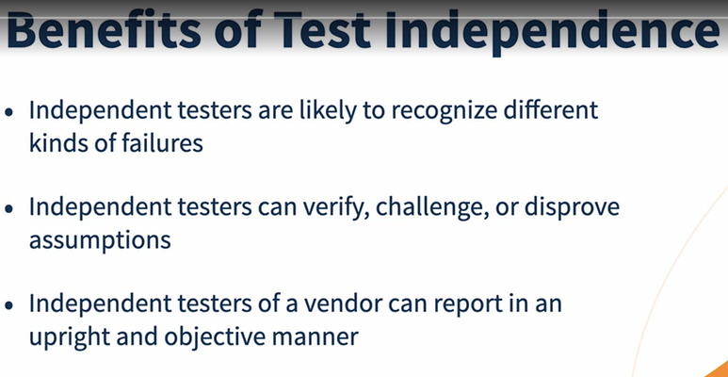

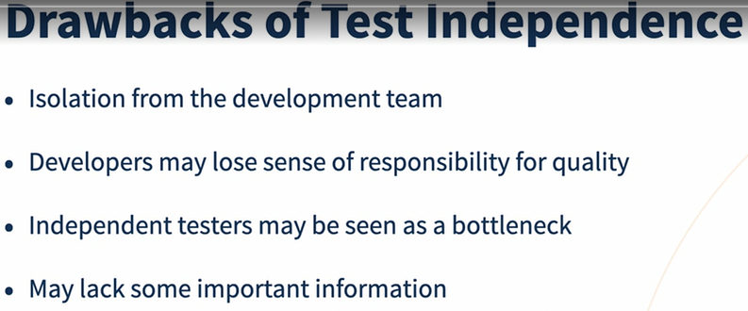

Tasks of a Test Manager

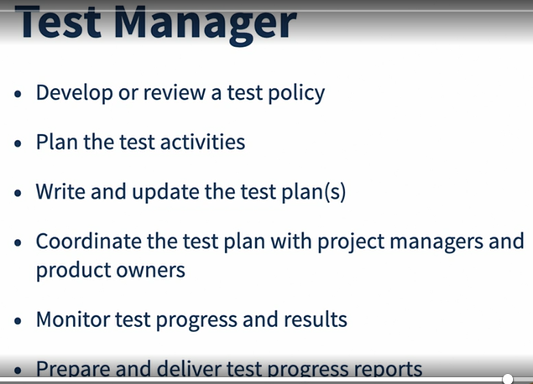

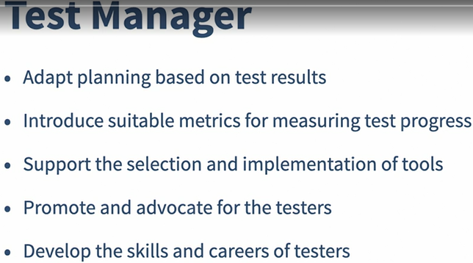

Typical test manager tasks may include: • Develop or review a test policy and test strategy for the organization • Plan the test activities by considering the context, and understanding the test objectives and risks. This may include selecting test approaches, estimating test time, effort and cost, acquiring resources, defining test levels and test cycles, and planning defect management • Write and update the test plan(s) • Coordinate the test plan(s) with project managers, product owners, and others • Share testing perspectives with other project activities, such as integration planning • Initiate the analysis, design, implementation, and execution of tests, monitor test progress and results, and check the status of exit criteria (or definition of done) and facilitate test completion activities • Prepare and deliver test progress reports and test summary reports based on the information gathered • Adapt planning based on test results and progress (sometimes documented in test progress reports, and/or in test summary reports for other testing already completed on the project) and take any actions necessary for test control • Support setting up the defect management system and adequate configuration management of testware • Introduce suitable metrics for measuring test progress and evaluating the quality of the testing and the product • Support the selection and implementation of tools to support the test process, including recommending the budget for tool selection (and possibly purchase and/or support), allocating time and effort for pilot projects, and providing continuing support in the use of the tool(s) • Decide about the implementation of test environment(s) • Promote and advocate the testers, the test team, and the test profession within the organization • Develop the skills and careers of testers (e.g., through training plans, performance evaluations, coaching, etc.)

Tasks of a Tester

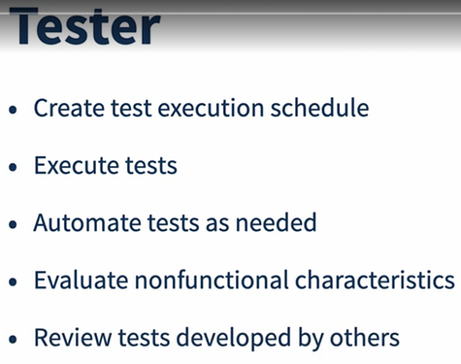

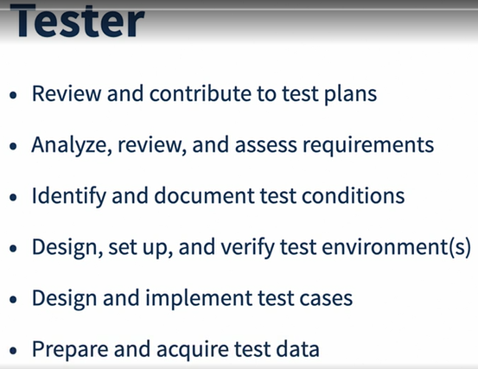

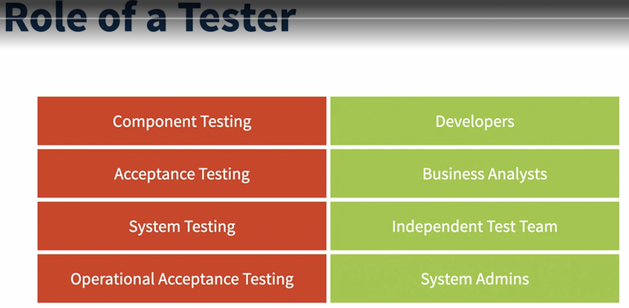

Typical tester tasks may include: • Review and contribute to test plans • Analyze, review, and assess requirements, user stories and acceptance criteria, specifications, and models for testability (i.e., the test basis) • Identify and document test conditions, and capture traceability between test cases, test conditions, and the test basis • Design, set up, and verify test environment(s), often coordinating with system administration and network management • Design and implement test cases and test procedures • Prepare and acquire test data • Create the detailed test execution schedule • Execute tests, evaluate the results, and document deviations from expected results • Use appropriate tools to facilitate the test process • Automate tests as needed (may be supported by a developer or a test automation expert) • Evaluate non-functional characteristics such as performance efficiency, reliability, usability, security, compatibility, and portability • Review tests developed by others

at the component testing level and the component integration testing level, the role of a tester is often done by developers. At the acceptance test level, the role of a tester is often done by business analysts, subject matter experts, and users. At the system test level and the system integration test level, the role of a tester is often done by an independent test team. At the operational acceptance test level, the role of a tester is often done by operations and/or systems administration staff.

Test Planning and Estimation

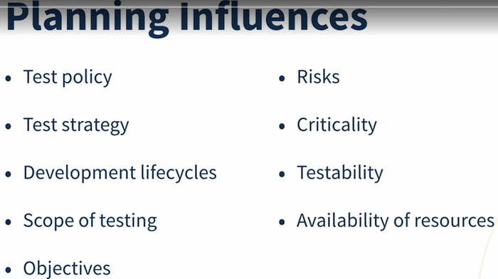

Purpose and Content of a Test Plan

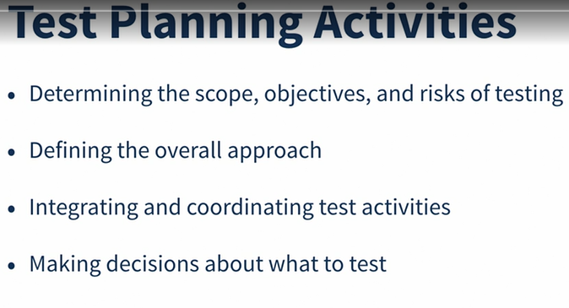

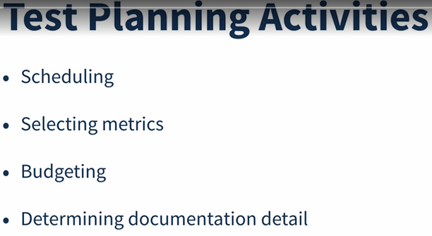

in a test plan: • Determining the scope, objectives, and risks of testing • Defining the overall approach of testing • Integrating and coordinating the test activities into the software lifecycle activities • Making decisions about what to test, the people and other resources required to perform the various test activities, and how test activities will be carried out • Scheduling of test analysis, design, implementation, execution, and evaluation activities, either on particular dates (e.g., in sequential development) or in the context of each iteration (e.g., in iterative development) • Selecting metrics for test monitoring and control • Budgeting for the test activities • Determining the level of detail and structure for test documentation (e.g., by providing templates or example documents)

Test Strategy and Test Approach

A test strategy provides a generalized description of the test process, usually at the product or organizational level.

Common types of test strategies include: • Analytical: This type of test strategy is based on an analysis of some factor (e.g., requirement or risk). Risk-based testing is an example of an analytical approach, where tests are designed and prioritized based on the level of risk. • Model-Based: In this type of test strategy, tests are designed based on some model of some required aspect of the product, such as a function, a business process, an internal structure, or a non-functional characteristic (e.g., reliability). Examples of such models include business process models, state models, and reliability growth models.

Methodical: This type of test strategy relies on making systematic use of some predefined set of tests or test conditions, such as a taxonomy of common or likely types of failures, a list of important quality characteristics, or company-wide look-and-feel standards for mobile apps or web pages. • Process-compliant (or standard-compliant): This type of test strategy involves analyzing, designing, and implementing tests based on external rules and standards, such as those specified by industry-specific standards, by process documentation, by the rigorous identification and use of the test basis, or by any process or standard imposed on or by the organization. • Directed (or consultative): This type of test strategy is driven primarily by the advice, guidance, or instructions of stakeholders, business domain experts, or technology experts, who may be outside the test team or outside the organization itself. • Regression-averse: This type of test strategy is motivated by a desire to avoid regression of existing capabilities. This test strategy includes reuse of existing testware (especially test cases and test data), extensive automation of regression tests, and standard test suites. • Reactive: In this type of test strategy, testing is reactive to the component or system being tested, and the events occurring during test execution, rather than being pre-planned (as the preceding strategies are). Tests are designed and implemented, and may immediately be executed in response to knowledge gained from prior test results. Exploratory testing is a common technique employed in reactive strategies.

While the test strategy provides a generalized description of the test process, the test approach tailors the test strategy for a particular project or release. The test approach is the starting point for selecting the test techniques, test levels, and test types, and for defining the entry criteria and exit criteria (or definition of ready and definition of done, respectively).

Entry Criteria and Exit Criteria (Definition of Ready and Definition of Done)

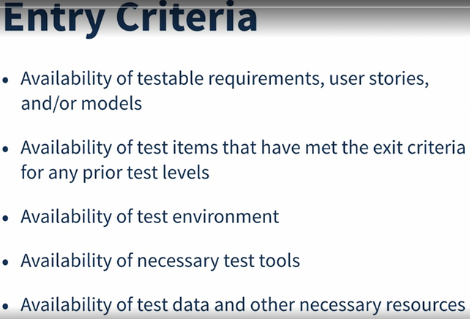

Entry criteria (more typically called definition of ready in Agile development) define the preconditions for undertaking a given test activity. If entry criteria are not met, it is likely that the activity will prove more difficult, more time-consuming, more costly, and more risky. Exit criteria (more typically called definition of done in Agile development) define what conditions must be achieved in order to declare a test level or a set of tests completed. Entry and exit criteria should be defined for each test level and test type, and will differ based on the test objectives.

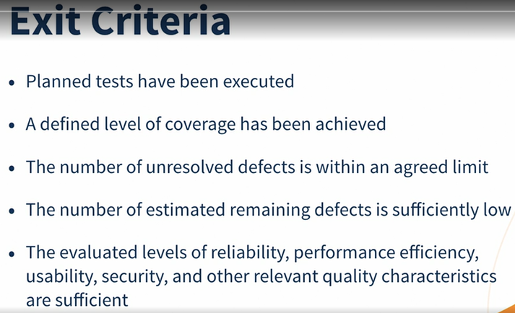

Typical entry criteria include: • Availability of testable requirements, user stories, and/or models (e.g., when following a modelbased testing strategy) • Availability of test items that have met the exit criteria for any prior test levels Availability of test environment • Availability of necessary test tools • Availability of test data and other necessary resources

Typical exit criteria include: • Planned tests have been executed • A defined level of coverage (e.g., of requirements, user stories, acceptance criteria, risks, code) has been achieved • The number of unresolved defects is within an agreed limit • The number of estimated remaining defects is sufficiently low • The evaluated levels of reliability, performance efficiency, usability, security, and other relevant quality characteristics are sufficient

Test Execution Schedule

Ideally, test cases would be ordered to run based on their priority levels, usually by executing the test cases with the highest priority first. However, this practice may not work if the test cases have dependencies or the features being tested have dependencies

Factors Influencing the Test Effort

Test effort estimation involves predicting the amount of test-related work that will be needed in order to meet the objectives of the testing for a particular project, release, or iteration

Product characteristics • The risks associated with the product • The quality of the test basis The size of the product • The complexity of the product domain • The requirements for quality characteristics (e.g., security, reliability) • The required level of detail for test documentation • Requirements for legal and regulatory compliance Development process characteristics • The stability and maturity of the organization • The development model in use • The test approach • The tools used • The test process • Time pressure People characteristics • The skills and experience of the people involved, especially with similar projects and products (e.g., domain knowledge) • Team cohesion and leadership Test results • The number and severity of defects found • The amount of rework required

Test Estimation Techniques

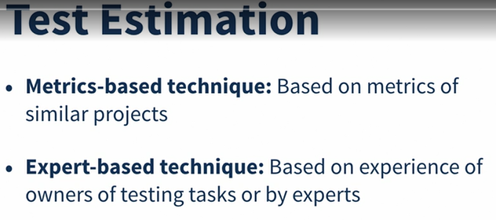

Two of the most commonly used techniques are: • The metrics-based technique: estimating the test effort based on metrics of former similar projects, or based on typical values • The expert-based technique: estimating the test effort based on the experience of the owners of the testing tasks or by experts

For example, in Agile development, burndown charts are examples of the metrics-based approach as effort remaining is being captured and reported, and is then used to feed into the team’s velocity to determine the amount of work the team can do in the next iteration; whereas planning poker is an example of the expert-based approach, as team members are estimating the effort to deliver a feature based on their experience

Test Monitoring and Control



The purpose of test monitoring is to gather information and provide feedback and visibility about test activities



Agile project's definition of done, are satisfied, such as meeting the targets for coverage of product risks, requirements, or acceptance criteria.

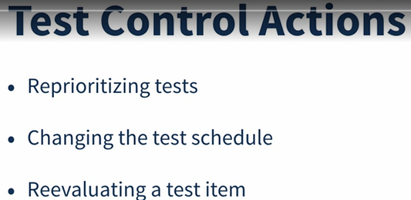

Examples of test control actions include: • Re-prioritizing tests when an identified risk occurs (e.g., software delivered late) • Changing the test schedule due to availability or unavailability of a test environment or other resources • Re-evaluating whether a test item meets an entry or exit criterion due to rework

Metrics Used in Testing

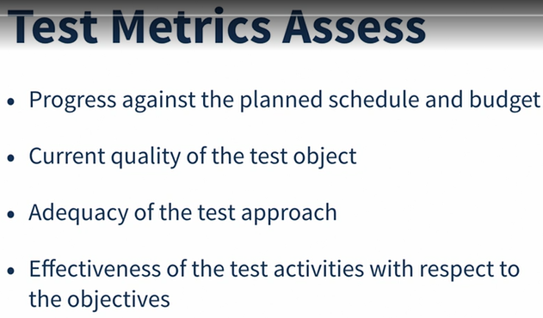

Metrics can be collected during and at the end of test activities in order to assess: • Progress against the planned schedule and budget • Current quality of the test object • Adequacy of the test approach • Effectiveness of the test activities with respect to the objectives

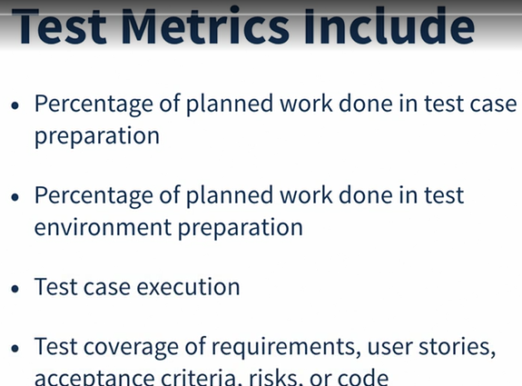

Common test metrics include: • Percentage of planned work done in test case preparation (or percentage of planned test cases implemented) • Percentage of planned work done in test environment preparation • Test case execution (e.g., number of test cases run/not run, test cases passed/failed, and/or test conditions passed/failed) • Defect information (e.g., defect density, defects found and fixed, failure rate, and confirmation test results) • Test coverage of requirements, user stories, acceptance criteria, risks, or code • Task completion, resource allocation and usage, and effort • Cost of testing, including the cost compared to the benefit of finding the next defect or the cost compared to the benefit of running the next test

Purposes, Contents, and Audiences for Test Reports

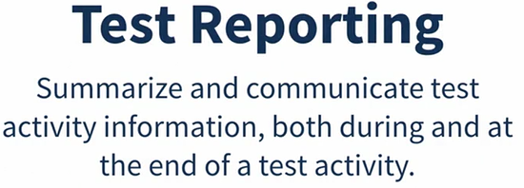

The purpose of test reporting is to summarize and communicate test activity information, both during and at the end of a test activity (e.g., a test level). The test report prepared during a test activity may be referred to as a test progress report, while a test report prepared at the end of a test activity may be referred to as a test summary report

test progress reports may also include:

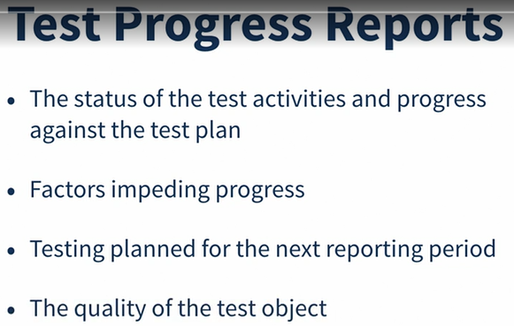

• The status of the test activities and progress against the test plan • Factors impeding progress • Testing planned for the next reporting period • The quality of the test object

Typical test summary reports may include: • Summary of testing performed • Information on what occurred during a test period • Deviations from plan, including deviations in schedule, duration, or effort of test activities • Status of testing and product quality with respect to the exit criteria or definition of done • Factors that have blocked or continue to block progress • Metrics of defects, test cases, test coverage, activity progress, and resource consumption. (e.g., as described in 5.3.1) • Residual risks (see section 5.5) • Reusable test work products produced

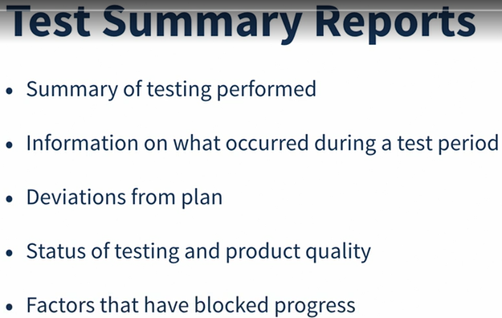

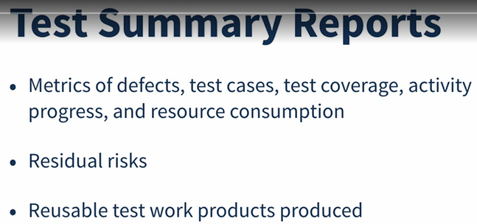

in Agile development, test progress reporting may be incorporated into task boards, defect summaries, and burndown charts, which may be discussed during a daily stand-up meeting

burndown charts - диаграмма, показывающая количество сделанной и оставшейся работы.

The type and amount of information that should be included for a technical audience or a test team may be different from what would be included in an executive summary report. In the first case, detailed information on defect types and trends may be important. In the latter case, a high-level report (e.g., a status summary of defects by priority, budget, schedule, and test conditions passed/failed/not tested) may be more appropriate.

Configuration Management

The purpose of configuration management is to establish and maintain the integrity of the component or system, the testware, and their relationships to one another through the project and product lifecycle. To properly support testing, configuration management may involve ensuring the following: • All test items are uniquely identified, version controlled, tracked for changes, and related to each other • All items of testware are uniquely identified, version controlled, tracked for changes, related to each other and related to versions of the test item(s) so that traceability can be maintained throughout the test process • All identified documents and software items are referenced unambiguously in test documentation

Risks and Testing

Definition of Risk

Risk involves the possibility of an event in the future which has negative consequences. The level of risk is determined by the likelihood of the event and the impact (the harm) from that event.

Product Risks (Quality)



Examples of product risks include: • Software might not perform its intended functions according to the specification • Software might not perform its intended functions according to user, customer, and/or stakeholder needs • A system architecture may not adequately support some non-functional requirement(s) • A particular computation may be performed incorrectly in some circumstances • A loop control structure may be coded incorrectly • Response-times may be inadequate for a high-performance transaction processing system • User experience (UX) feedback might not meet product expectations

project risks

Project issues: o Delays may occur in delivery, task completion, or satisfaction of exit criteria or definition of done o Inaccurate estimates, reallocation of funds to higher priority projects, or general costcutting across the organization may result in inadequate funding o Late changes may result in substantial re-work

Organizational issues: o Skills, training, and staff may not be sufficient o Personnel issues may cause conflict and problems o Users, business staff, or subject matter experts may not be available due to conflicting business priorities

Political issues: o Testers may not communicate their needs and/or the test results adequately o Developers and/or testers may fail to follow up on information found in testing and reviews (e.g., not improving development and testing practices) o There may be an improper attitude toward, or expectations of, testing (e.g., not appreciating the value of finding defects during testing)

Technical issues: o Requirements may not be defined well enough o The requirements may not be met, given existing constraints o The test environment may not be ready on time o Data conversion, migration planning, and their tool support may be late o Weaknesses in the development process may impact the consistency or quality of project work products such as design, code, configuration, test data, and test cases o Poor defect management and similar problems may result in accumulated defects and other technical debt

Supplier issues: o A third party may fail to deliver a necessary product or service, or go bankrupt o Contractual issues may cause problems to the project

Risk-based Testing and Product Quality

Risk is used to focus the effort required during testing. It is used to decide where and when to start testing and to identify areas that need more attention

A risk-based approach to testing provides proactive opportunities to reduce the levels of product risk. It involves product risk analysis, which includes the identification of product risks and the assessment of each risk’s likelihood and impact. The resulting product risk information is used to guide test planning, the specification, preparation and execution of test cases, and test monitoring and control. Analyzing product risks early contributes to the success of a project.

In a risk-based approach, the results of product risk analysis are used to: • Determine the test techniques to be employed • Determine the particular levels and types of testing to be performed (e.g., security testing, accessibility testing) • Determine the extent of testing to be carried out • Prioritize testing in an attempt to find the critical defects as early as possible • Determine whether any activities in addition to testing could be employed to reduce risk (e.g., providing training to inexperienced designers)

Defect Management

False positives come into **play when a test case fails**, but in actuality there is no bug and/or the functionality is working correctly. False negatives, on the other hand, are given when the test case passes, but there is in fact a bug present in the system and/or the functionality is not working as it should

False positives – not a bug, but test failed

For example, a test may fail when a network connection is broken or times out

False negatives – a bug but test case passed

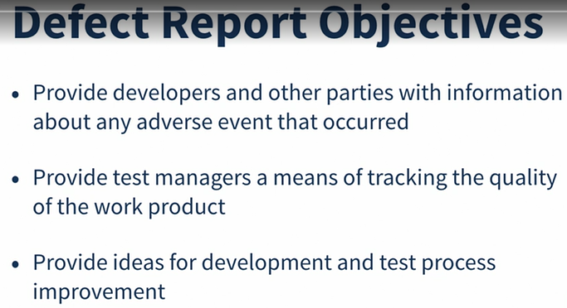

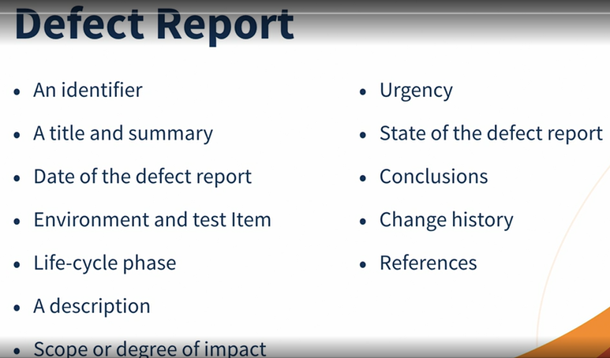

Tool Support for Testing

Keywords

data-driven testing, keyword-driven testing, test automation, test execution tool, test management tool

Test tools can be used to support one or more testing activities. Such tools include: • Tools that are directly used in testing, such as test execution tools and test data preparation tools • Tools that help to manage requirements, test cases, test procedures, automated test scripts, test results, test data, and defects, and for reporting and monitoring test execution • Tools that are used for analysis and evaluation • Any tool that assists in testing (a spreadsheet is also a test tool in this meaning)

Test Tool Classification

Examples of tools that support management of testing and testware include: • Test management tools and application lifecycle management tools (ALM) • Requirements management tools (e.g., traceability to test objects) • Defect management tools

Configuration management tools • Continuous integration tools (D)

Tool support for test execution and logging

Test execution tools (e.g., to run regression tests) • Coverage tools (e.g., requirements coverage, code coverage (D)) • Test harnesses (D)

Benefits and Risks of Test Automation

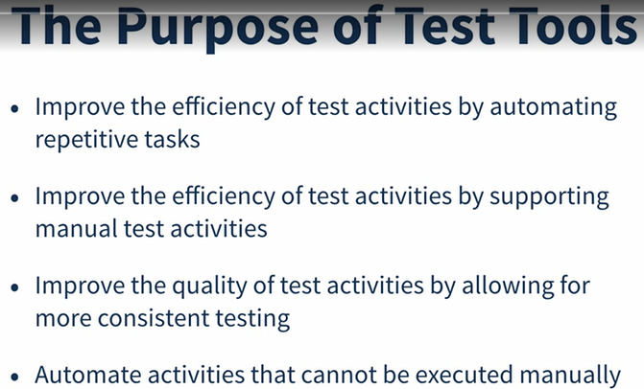

Potential benefits of using tools to support test execution include

Reduction in repetitive manual work (e.g., running regression tests, environment set up/tear down tasks, re-entering the same test data, and checking against coding standards), thus saving time

Greater consistency and repeatability (e.g., test data is created in a coherent manner, tests are executed by a tool in the same order with the same frequency, and tests are consistently derived from requirements) • More objective assessment (e.g., static measures, coverage) • Easier access to information about testing (e.g., statistics and graphs about test progress, defect rates and performance)

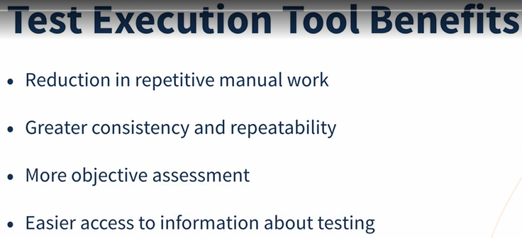

Potential risks of using tools to support testing include: • Expectations for the tool may be unrealistic (including functionality and ease of use) • The time, cost and effort for the initial introduction of a tool may be under-estimated (including training and external expertise) • The time and effort needed to achieve significant and continuing benefits from the tool may be under-estimated (including the need for changes in the test process and continuous improvement in the way the tool is used) • The effort required to maintain the test work products generated by the tool may be underestimated • The tool may be relied on too much (seen as a replacement for test design or execution, or the use of automated testing where manual testing would be better) • Version control of test work products may be neglected • Relationships and interoperability issues between critical tools may be neglected, such as requirements management tools, configuration management tools, defect management tools and tools from multiple vendors • The tool vendor may go out of business, retire the tool, or sell the tool to a different vendor • The vendor may provide a poor response for support, upgrades, and defect fixes • An open source project may be suspended • A new platform or technology may not be supported by the tool • There may be no clear ownership of the tool (e.g., for mentoring, updates, etc.)

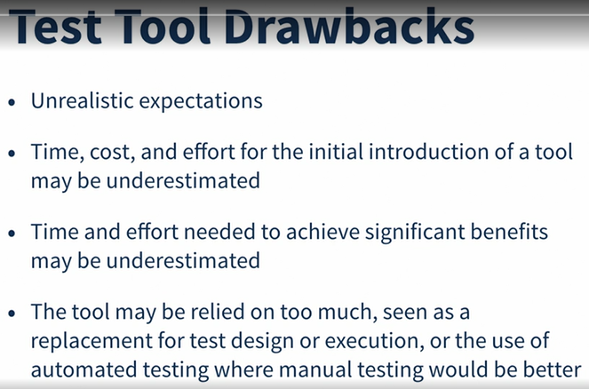

Test execution tools

Capturing test approach: Capturing tests by recording the actions of a manual tester seems attractive, but this approach does not scale to large numbers of test scripts. A captured script is a linear representation with specific data and actions as part of each script. This type of script may be unstable when unexpected events occur, and require ongoing maintenance as the system’s user interface evolves over time.

Data-driven test approach: This test approach separates out the test inputs and expected results, usually into a spreadsheet, and uses a more generic test script that can read the input data and execute the same test script with different data.

Keyword-driven test approach: This test approach, a generic script processes keywords describing the actions to be taken (also called action words), which then calls keyword scripts to process the associated test data.

Model-Based testing (MBT) tools enable a functional specification to be captured in the form of a model, such as an activity diagram. This task is generally performed by a system designer. The MBT tool interprets the model in order to create test case specifications which can then be saved in a test management tool and/or executed by a test execution tool

Test management tools

Test management tools often need to interface with other tools or spreadsheets for various reasons, including: • To produce useful information in a format that fits the needs of the organization • To maintain consistent traceability to requirements in a requirements management tool • To link with test object version information in the configuration management tool

Effective Use of Tools

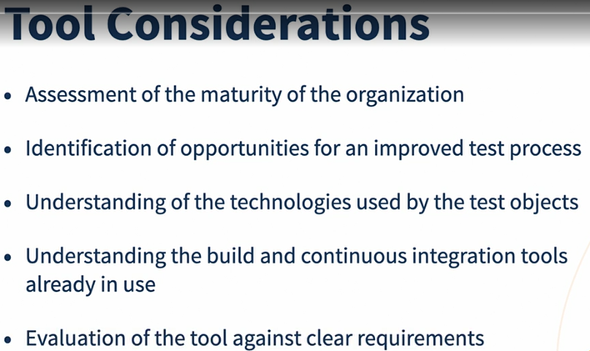

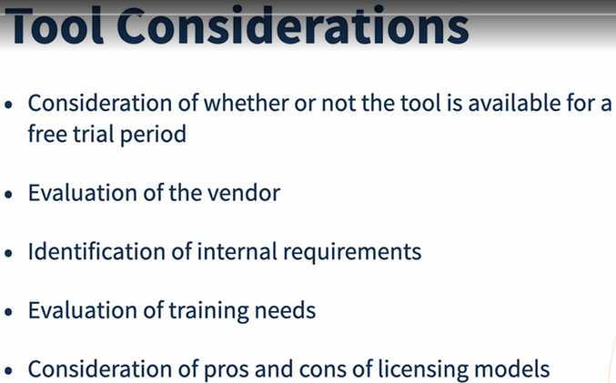

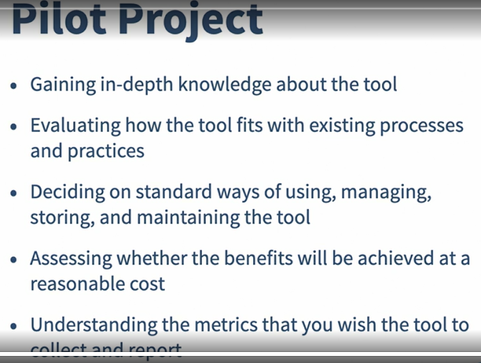

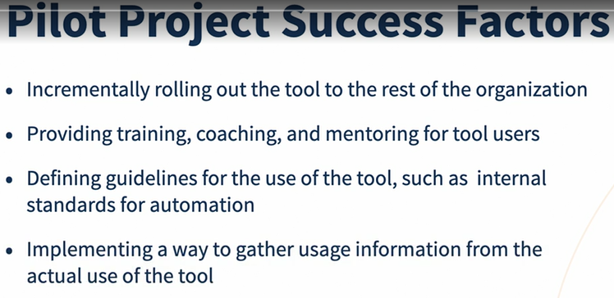

**Регрессоинное тестирование** (regression testing) — обобщённое название для всех видов тестирования программного обеспечения, направленных на обнаружение ошибок в уже протестированных участках исходного кода.

Слово «тест» в контексте я использую достаточно либерально, потому что модульные тесты в каком-то смысле тестами не являются. Они ничего не испытывают. Я имею в виду, что при запуске модульного теста вы обычно не обнаруживаете, что какой-то код не работает. Вы это обнаруживаете во время написания теста, поскольку вы будете менять код до тех пор, пока тест не станет зелёным.

В процессе написания модульного теста вы обнаруживаете, делает ли код то, что он должен или нет, и будете менять код до тех пор, пока тест не будет пройден.

Часто модульное тестирование путают с интеграционным тестированием. Некоторые «модульные тесты» проверяют более одного класса или тестируют большие единицы кода. Множество разработчиков утверждают, что они пишут модульные тесты, хотя на деле пишут whitebox-тесты на низком уровне. Не стоит спорить с этими ребятами. Просто знайте, что на самом деле они пишут интеграционные тесты, а настоящие модульные тесты изолированно от других частей проверяют наименьшую единицу кода.

**Ценность модульного тестирования**

**Первая — улучшить дизайн кода.**

Когда вы пишете правильные модульные тесты, вы вынуждаете себя изолировать наименьшую единицу кода. Эти попытки приведут к тому, что вы можете обнаружить проблемы в структуре самого кода. Вам может быть очень сложно изолировать проверочный класс и не включать его зависимости, и это может заставить вас понять, что ваш код слишком тесно связан.

Садясь за написание модульного теста, вы внезапно можете обнаружить (и поверьте, так бывает!), что вы понятия не имеете, что должен делать код. Соответственно, вы никак не сможете написать для него модульный тест.

И, конечно, вы можете найти реальную ошибку в реализации кода, поскольку модульный тест заставляет вас думать о нестандартных вариантах и проверять разные наборы входных данных, которые вы, возможно, не учли.

В жизненном цикле разработки программного обеспечения модульное тестирование является скорее оценочной деятельностью, чем тестирующей.

**Вторая основная цель модульного тестирования** — создать автоматизированный набор регрессионных тестов, который может работать как спецификация поведения программного обеспечения на низком уровне.

Регрессионное тестирование намного эффективнее на более высоком уровне, когда тестируется код, как «чёрный ящик», потому что на этом уровне внутренняя структура кода может быть изменена, в то время как внешнее поведение, как ожидается, останется прежним.

Подход TDD заключается в том, что прежде, чем написать какой-то код, вы сначала пишете тест, который будет служить спецификацией, то есть определять, что должен делать этот код.

Другая важная роль TDD заключается в сохранении и оптимизации кода. Поддержка кода — дорогое удовольствие.

Существует принцип разработки программного обеспечения под названием YAGNI (you ain’t going to need it), или «вам это не понадобится». TDD предотвращает YAGNI.

Очень мало классов существует в полной изоляции. Вместо этого у них есть зависимости, и эти зависимости имеют зависимости и так далее. Чтобы справиться с такими ситуациями, ветеран TDD использует макеты-пустышки (Mock), которые помогают изолировать отдельные классы, подменяя объекты в зависимых модулях.

Introduction and Objectives for Test Automation